
Medicare Remit Easy Print
User Guide
Version 4.61
May 2025

This software was developed by the Centers for Medicare & Medicaid Services (CMS) for use by Medicare providers/suppliers to view and print a Health Insurance Portability and Accountability Act (HIPAA) compliant Medicare 835. Medicare has no liability and takes no responsibility for any other use of this software.

© 2025 Sponsored by the Centers for Medicare & Medicaid Services (CMS) under contract HHSN-316-2012-00023W / HHSM-500-2016-00005U – DME Shared System Maintenance

This document contains confidential and proprietary information, which shall not be used, disclosed, or reproduced without the express written consent of CMS.

Table of Contents

Table of Contents 1
About Medicare Remit Easy Print 4
Informational 4
What’s New 4
Differences between MREP Remittance Advices and Shared System ERAs 5
About This Guide 6
Need Assistance? 6
PC Requirements 6
Operating System Requirements 7
How Does Medicare Remit Easy Print Get Medicare Remittance Info? 9
Information for Administrators 9
Network Installations 9
Pre-Installation Checklist for Installation on a Network 10
Installing Medicare Remit Easy Print on a Network 11
Before You Install Medicare Remit Easy Print on a Network 11
How to Install Medicare Remit Easy Print on the Network 11
Installing the Medicare Remit Easy Print Group Code on a PC 15
How to Install the Medicare Remit Easy Print Group Code 15
How to Know that the Medicare Remit Easy Print Group Code Install Completed Successfully 15
PC Installations 17
Getting Started 17
Pre-Installation Checklist for Installation on a PC 18
Installing Medicare Remit Easy Print 19
Before You Install Medicare Remit Easy Print 19
How to Install Medicare Remit Easy Print on Your PC 19
Starting Medicare Remit Easy Print 24
Before You Start Medicare Remit Easy Print 24
How to Start Medicare Remit Easy Print 24
Locating MREP and MREP File Locations on Your PC/Network 28
Locating the MREP Application on Your PC/Network – Icon Available 28
Locating the MREP Application on Your PC/Network – Icon not Available 30
Identifying Easy Print File Locations 32
Uninstalling Medicare Remit EasyPrint 35
Online Help System 37
How to Access the Online Help System 37
How to Use the Contents Tab 39
How to Use the Index Tab 41
How to Use the Search Tab 42
How to Close the Medicare Remit Easy Print Help Window 43
Importing HIPAA 835 files 44
Before You Import the HIPAA 835 File 44
Import File Name Format 44
How to Import the HIPAA 835 File 45
How to Automatically Import the HIPAA 835 File 47
What to Do with an Import Error Message 50
Import Exception Summary Window/Report 51
Working with MREP Remittance Advices 53
How to View a List of Claims for an MREP Remittance Advice 53
How to View the Detail for a Claim 55
How to View the Total Amounts for a Remittance Advice 59
How to View the Data in the Import File 61
How to View the CARC and RARC Codes 63
How to Look up a CARC/RARC Code, Group Code, or CORE Business Scenario 65
How to Update (Import) the CARC/RARC Codes, Group Codes, and CORE Business Scenarios 66
How to Print a List of Claims 70
How to Print the Detail for a Claim 72
How to Print the Remittance Advice Summary 74
Searching Payment Information 76
How to Search Payment Information 77
Making Sense of the Claim List Tab 81
Display Claim(s) 83
Making Sense of the Claim Detail Tab 85
Making Sense of the Remit Summary Tab 88
Making Sense of the Data View Tab 90
Making Sense of the Search Tab 91
Making Sense of the Glossary Tab 92
Working with Reports 93
Making Sense of the Denied Service Lines Report 94
Making Sense of the Adjusted Service Lines Report 95
Making Sense of the Deductible Service Lines Report 96
Making Sense of the Coinsurance Service Lines Report 97
Making Sense of the Deductible/Coinsurance Service Lines Report 98
Making Sense of the COB Claims Report 99
Making Sense of the Non-COB Claims Report 100
Making Sense of the MSP Claims Report 101
Making Sense of the Non-MSP Claims Report 102
Making Sense of the Other Adjustments Report 103
Making Sense of the Entire Remittance Report 104
How to Print the Denied Service Lines Report 105
How to Export the Denied Service Lines Report 109
How to Print the Adjusted Service Lines Report 113
How to Export the Adjusted Service Lines Report 117
How to Print the Deductible Service Lines Report 121
How to Export the Deductible Service Lines Report 126
How to Print the Coinsurance Service Lines Report 131
How to Export the Coinsurance Service Lines Report 137
How to Print the Deductible/Coinsurance Service Lines Report 142
How to Export the Deductible/Coinsurance Service Lines Report 147
How to Print the COB Claims Report 152
How to Export the COB Claims Report 157
How to Print the Non-COB Claims Report 161
How to Export the Non-COB Claims Report 166
How to Print the MSP Claims Report 171
How to Export the MSP Claims Report 177
How to Print the Non-MSP Claims Report 182
How to Export the Non-MSP Claims Report 187
How to Print the Other Adjustments Report 192
How to Export the Other Adjustments Report 196
How to Print the Entire Remittance Report 200
Housekeeping for the Import Files 203
Archiving Import Files 203
How to Archive Import files 203
Restoring Import files 206
How to Restore Import files 206
Deleting Import files 207
How to Delete an Import file 207
Using Keystroke Shortcuts 210
Appendix A: MREP RA/HIPAA 835v5010A1 Segment Field Crosswalk 213
Appendix B: Abbreviation and Acronym Glossary 221

About Medicare Remit Easy Print
Medicare Remit Easy Print enables you to print Medicare Part B and DME MAC HIPAA 835v5010A1 files in a format that is similar to the Electronic Remittance Advice (ERAs).You can use Medicare Remit Easy Print to:
• view MREP Remittance Advices (see page 53)
• search MREP Remittance Advices (see page 77)
• print MREP Remittance Advices (see page 200)
• print reports about MREP Remittance Advices (see page 105)
You can install Medicare Remit Easy Print on a PC or on a network (see Pre-Installation Checklist for Installation on a PC).
For general information about remittances, see https://www.cms.gov/Outreach-and-Education/Medicare-Learning-Network-MLN/MLNProducts/Downloads/Remit-Advice-Overview-Fact-Sheet-ICN908325.pdf

Informational
- MREP accepts remittances in the X12 835V5010A1 and X12 835V4010A1 formats.
- MREP Version 4.61 includes the CARC and RARC lists published regularly by the WPC (Washington Publishing Company) and Code Combination Business Scenarios published by the CAQH/CORE. Updated code lists will be made available individually and can be imported into MREP to keep the codes current. For more information, see How to View the CARC and RARC Codes.

What’s New
- As CMS moves from using HICNs for patient identification to using Medicare Beneficiary Identification (MBI) Numbers, MREP screens and reports are being updated, changing headers and labels from HICN or HIC to MID (Medicare Identification number). The MID field could be populated with a HICN or an MBI. The primary MID will be populated with the Submitted ID (2100 NM109 value when 2100 NM101 = QC). If an alternate MID is transmitted in the 835 Corrected Patient ID Segment (2100 NM109 value when 2100 NM101 = 74), it appears on the remittance below the primary MID. A MID can be a HICN or a MBI.
Note: When viewing historical 4010A1 remittances, a Corrected Patient ID will continue to replace the Submitted Patient ID.

Differences between MREP Remittance Advices and Shared System ERAs
It is important to understand that the Medicare Remit Easy Print Remittance Advice is a representation of the HIPAA 835v4010A1 or the HIPAA 835v5010A1 transaction data. Although CMS attempted to make the Medicare Remit Easy Print generated Remittance Advice very similar to the Shared System Maintainer generated SPR (received by mail), the printed information and data content at times may differ. So, the two can be compared as long as there is an understanding of why they differ.
For example, the HIPAA 835v5010A1 transaction data contains reversal (mother) claim information and, in turn, the Medicare Remit Easy Print Remittance Advice displays this information and uses it in the calculation of the entire remittance total. The CMS systems that create the file for the SPR received by mail have the ability to net the claim information for adjustments prior to generating the SPR. The HIPAA 5010A1 transaction has no facility to convey the information to allow MREP to net the claim information for adjustments prior to generating the Medicare Remit Easy Print Remittance Advice and, therefore, must do a complete back-out of the original claim and build a new adjusted claim with the modified information.
Item | Medicare Remit Easy Print | Shared System
Adjustments | You must calculate the net.  Claim Example #1  Original Claim 000000000001000  Provider Paid $100.00  Adjustment Claim 000000000001001  Provider Paid $80.00  Provider Paid $20.00 (overpayment)  Claim Example #2  Original Claim 000000000002000  Provider Paid $100.00  Adjustment Claim 000000000002001  Provider Paid $150.00  Provider Paid $50.00 (underpayment) | The net was calculated for you.  Claim Example #1  Adjustment Claim 000000000001001  Provider Paid $20.00  Claim Example #2  Adjustment Claim 000000000002001  Provider Paid $50.00
PREV PD | Always blank | Calculated for you
General Messages for Suppliers/  Providers (Provider Bulletin Board) | Not shown | Shown

About This Guide
All personal health information has been replaced with fictitious information.
To use this guide, you need to have a working knowledge of Microsoft Windows.
For example, you need to know how to:
    - access your desktop,
    - use the Start menu, and
    - use Microsoft Windows Explorer.
You also need to know common Microsoft Windows terminology. For example, Start > Programs refers to the Programs option on the Start menu.

Need Assistance?
If you need assistance, please contact:
Email Your Medicare contractor
Phone Your Medicare contractor

PC Requirements
Recommended Speed: 2.0 gigahertz (GHz) or faster
RAM (Random Access Memory) 256 megabytes (Mb) or above
Hard Disk Space 1 gigabyte (GB)
Display 1024x768 High Color (16-bit)

Operating System Requirements
Recommended: Windows 7 and higher

.NET Framework: 2.0 SP2
This application uses Visual Basic.Net, a Microsoft compatible language and, like many applications that require an MS Windows platform, MREP requires a .NET framework. More than likely one or more.NET frameworks were pre-installed on your Windows operating system or Windows Update downloaded a newer version on your PC. You must have .NET framework version 2.0 SP2 on each PC using the MREP Application.
Note: .NET frameworks 3.0, 3.5, and 4.0 include the 2.0 SP2 framework so if one of these frameworks is present, .NET 2.0 SP2 does not need to be installed separately. Windows 8 users may need to install or enable the .NET 3.5 framework 3.5 on each PC that uses MREP.
If you do not have the necessary framework installed, you may receive a message stating that this version of the framework is required during the installation process and prompting you to install it.
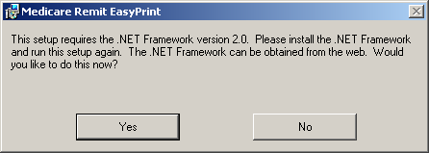
By clicking Yes—and if you have access to the Internet—you are redirected to the Microsoft web site to download the .NET framework 2.0 SP. Download NetFx20SP2_x86.exe for 32-bit systems or NetFx20SP2_64.exe for 64-bit systems. We do not recommend that you download a beta version of the .NET framework if you are presented with this option on the Microsoft web site.
Outside of the application installation process, you may also visit the link to Microsoft .NET Framework Version 2.0 Service Pack 2 at the Microsoft website to transport directly to the location on the Microsoft web site to download the 2.0 SP2 .NET framework version.
If you want to learn more about the 2.0 SP2 .NET Framework version and/or determine if you need to install this version, you may visit
.Net Framework Developer Center at the Microsoft website.
Please follow the directions within the web site when using this link.
If you do not have access to the Internet and you receive a message to update your .NET framework, you have to obtain a copy of the .NET framework from Microsoft. The Medicare Remit Easy Print application does not work without the appropriate .NET framework installed on each machine accessing the application.

Decompression Application: To download the Medicare Remit Easy Print program from your Medicare contractor’s web site, you must have the following:
• Access to the Internet.
• 7-Zip, WinZip, or a compatible decompression application to extract files. If you do not have a decompression application, you can go to a number of web sites to acquire one (For example: http://www.winzip.com/downwzeval.htm).

How Does Medicare Remit Easy Print Get Medicare Remittance Info?
You have to import Medicare remittance information into Medicare Remit Easy Print. For more information about importing, see Importing HIPAA 835 files.
The files that you import are the ANSI files. For more information about the format of these files, see Appendix A: MREP RA/HIPAA 835v5010A1 Segment Field Crosswalk.
When Medicare Remit Easy Print reformats and saves a copy of an HIPAA 835 file, it is called the Import file. For information about how EasyPrint names the Import files, see Import File Name Format.
Medicare Remit Easy Print keeps all of the Import files in the Import folder in the Medicare Remit EasyPrint directory.

Information for Administrators
Medicare Remit Easy Print can be installed on a PC or network.
To install MREP:
- on a PC, see PC Installations
- on a network, see Installing Medicare Remit Easy Print on a Network

Network Installations
Medicare Remit Easy Print Directory
There must be sufficient space on the network to save the Import file(s).
The Medicare Remit Easy Print software takes about 4000 KB.
Users must have Read/Write access to the directory where the software is installed because the software creates files and saves them using the user’s security privileges to the directory.
Medicare Remit Easy Print Access
If you need to make Medicare Remit Easy Print available to all users who log on, indicate this during the installation procedure.
Group Code MSI file
When installing the application on a network, each PC that accesses the application must have installed the Group Code MSI file.

Pre-Installation Checklist for Installation on a Network
Before you install Medicare Remit Easy Print, you need to complete these steps:
Step | Description | Completed
1 | Check that the network, all PCs, and printers meet all requirements. | No data
2 | Find out where to save the Medicare Remit Easy Print installation software on your C:\ drive or Desktop.  The file name is: Medicare Remit Easy Print.msi  Write the location here: | No data
3 | Find out where to save the Medicare Remit Easy Print Group Code .msi file on your C:\ drive or Desktop:  The file name is: GroupCode.msi  Write the location here:  Note: The GroupCode.msi must be installed on all PCs executing EasyPrint from a network location or any PCs that access network locations from within the application.  When installed on a network drive, only the EasyPrint shortcut and the GroupCode.msi package need to be installed on PCs executing the application. There is no need to install the application on each individual PC.  To ensure each client PC can access the application: from the client PC, navigate to the network location where Medicare Remit Easy Print is installed, right click on the EasyPrint.exe file, and select “create shortcut”. This shortcut can then be copied to the desktop of the client PC. This step is necessary in the event the network drive mapping is different on the client PC. | No data
4 | Create a folder called HIPAA 835 files and make sure that all users know the location.  This folder must have adequate security for PHI.  Write the location for the HIPAA 835 files here: | No data
5 | Create a directory on the server for the Medicare Remit Easy Print installation.  This directory must have adequate security for PHI. | No data

Installing Medicare Remit Easy Print on a Network
When you install Medicare Remit Easy Print on a network:
    - install Medicare Remit Easy Print on the network
    - install the Medicare Remit Easy Print Group Code on every PC accessing the application

Before You Install Medicare Remit Easy Print on a Network
Before you install Medicare Remit Easy Print:
    - complete the Pre-Installation Checklist for Installation on a Network

How to Install Medicare Remit Easy Print on the Network
Important!
If this download cannot get past your network firewall, please contact your Medicare contractor.
Download Instructions
From the CMS website: https://www.cms.gov/Research-Statistics-Data-and-Systems/CMS-Information-Technology/AccesstoDataApplication/MedicareRemitEasyPrint.html:
- Select the Medicare Remit Easy Print link.
- Click the Medicare Remit Easy Print zip file. Depending on your browser, the file saves to your Downloads folder or you can save the file to the location you noted on the Pre-Installation Checklist for Installation on a Network.
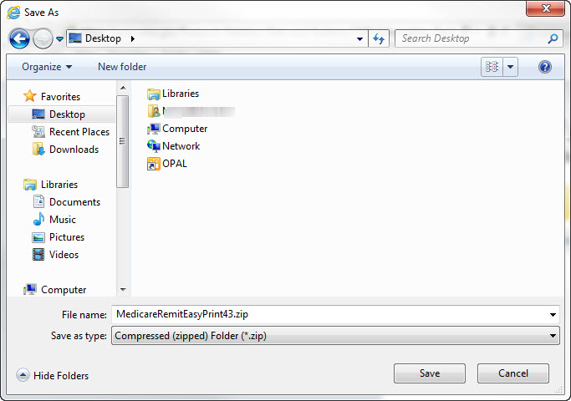
- Double click the .zip file.
.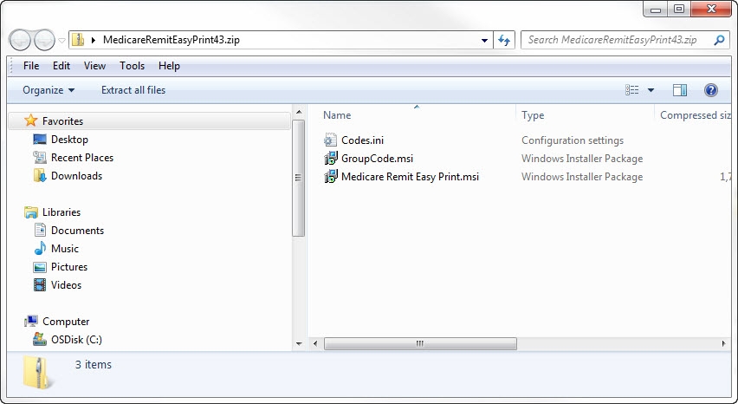
Installation Instructions
- Make sure you know the location of the Medicare Remit Easy Print.msi file (Step 2 of the Pre-Installation Checklist for Installation on a Network.)
- Open Microsoft Windows Explorer and find the Medicare Remit Easy Print.msi file.
- Double-click the Medicare Remit Easy Print.msi file:
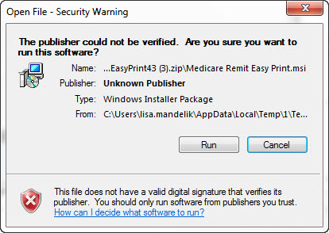
- The Medicare Remit Easy Print Setup Wizard opens.
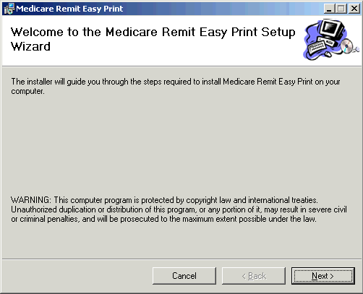
- Click Next.
The Select Installation Folder window opens. 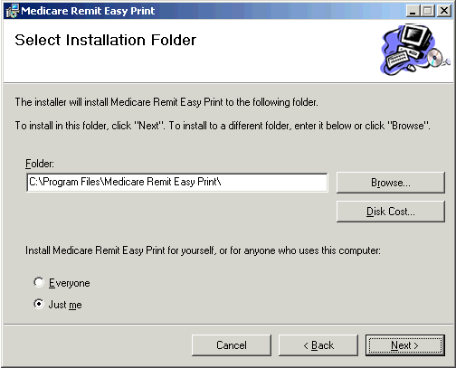
T:\Easy Print Files\
- Click Browse to find the network location for the install. The applications and associated files will download to that location.
- On the following line, write the location where you are saving the application and where all of the associated folders and files are to be saved:
________________________________________________________
Note: Do not install Easy Print in the C:\Program Files directory.
- Select Everyone and click Next.
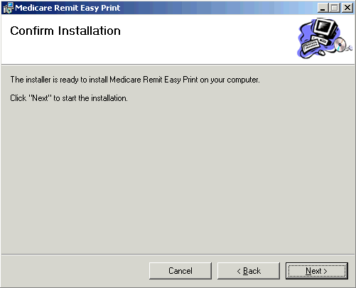
The Confirm Installation window opens.
- Click Next.
When the installation finishes, the Installation Complete window opens.
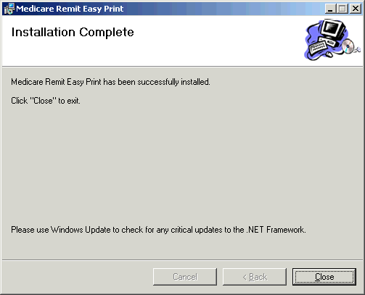
- Click Close.
- Complete the Medicare Easy Print Group Code installation on each PC. See Installing the Medicare Remit Easy Print Group Code on a PC for more information.
What Happens During the Installation Process?
The following items are created and placed in the directory you designated under the Medicare Remit Easy Print folder in Step 6 of the Installation Instructions:
    - EasyPrint.exe
    - Easy Print icon - shortcut
    - Import folder – location of active converted HIPAA 835 files
    - Archive folder – location of inactive converted HIPAA 835 files. Inactive files are files not currently viewed in the application.
    - Native 835 folder – default location from which to import 835 files
    - Report Export folder - where exported Report files are stored
    - Resource folder - internal folder to application

Installing the Medicare Remit Easy Print Group Code on a PC
After you install the Medicare Remit Easy Print application on the network, you must install the GroupCode.msi file on every PC that needs to access the application.

How to Install the Medicare Remit Easy Print Group Code
- Make sure you know the location of the Medicare Remit Easy Print Group Code file (Step 3 of the Pre-Installation Checklist for Installation on a PC.
- Open Microsoft Windows Explorer and find the Medicare Remit Easy Print Group Code.msi file.
- Double-click the Medicare Remit Easy Print Group Code.msi file.
The installation completes without opening any windows or displaying any messages.

How to Know that the Medicare Remit Easy Print Group Code Install Completed Successfully
If the installation DID complete successfully, the PC user can open Medicare Remit Easy Print.
If the installation DID NOT complete successfully, the PC user cannot open Medicare Remit Easy Print and sees this unhandled exception dialog box.
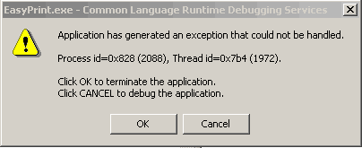
Click OK and install the Medicare Remit Easy Print Group Code again.

PC Installations
HIPAA 835 File Location
Users must know the location from which to download the HIPAA 835 file they receive from their Medicare contractor.
Medicare Remit Easy Print Directory
There must be sufficient space on the PC for Medicare Remit Easy Print to save the Import file(s).
The Medicare Remit Easy Print software takes about 4000 KB. The size of the Import file(s) is dependent upon the number of claims found in the HIPAA 835 file.
Medicare Remit Easy Print Access

The default for installing Medicare Remit Easy Print is to have it be accessible only to a single user on a PC.

Getting Started
To get started:
- Complete the Pre-Installation Checklist for Installation on a PC.

- Install Medicare Remit Easy Print on your PC (see page 19).

Pre-Installation Checklist for Installation on a PC
Before you install Medicare Remit Easy Print, you need to complete these steps:
Step | Description | Completed
1 | Check to be sure that your PC and printer meet all requirements. | No Data
2 | Find out where to save the Medicare Remit Easy Print install file.  The file name is: Medicare Remit Easy Print.msi  Write the location here: __________________________________________ | No data
3 | Find out where to save the HIPAA 835 files.  Write the location here: __________________________________________ | No data
4 | The default installation location is C:\Medicare Remit EasyPrint. If you want to install the application in another location, create a directory on the PC for the Medicare Remit EasyPrint installation.  This directory must have adequate security for PHI.  Note: Do not install Easy Print into the C:\Program Files directory. | No data

Installing Medicare Remit Easy Print

Before You Install Medicare Remit Easy Print
Before you install Medicare Remit Easy Print:
Complete the Pre-Installation Checklist for Installation on a PC.

How to Install Medicare Remit Easy Print on Your PC
Download Instructions
From the CMS website: https://www.cms.gov/Research-Statistics-Data-and-Systems/CMS-Information-Technology/AccesstoDataApplication/MedicareRemitEasyPrint.html:
- Select the Medicare Remit Easy Print link.
- Click the Medicare Remit Easy Print zip file. Depending on your browser, the file saves to your Downloads folder or you can save the file to the location you noted on the Pre-Installation Checklist for Installation on a PC.
- Double click the .zip file.
.
Installation Instructions
- Make sure you know the location of the Medicare Remit Easy Print.msi file (Step 2 of the Pre-Installation Checklist for Installation on a PC)
- Open Microsoft Windows Explorer and find the Medicare Remit Easy Print.msi file.
- Double-click the Medicare Remit Easy Print.msi file:
- The Medicare Remit Easy Print Setup Wizard opens.
- Click Next.
The Select Installation Folder window opens.
T:\Easy Print Files\
- If you want to accept the default installation location, click Next. To install in another location, click Browse to find the location for the install. The applications are downloaded to the location you selected.
- On the following line, write the location where you are saving the application and where all of the associated folders and files are to be saved:
________________________________________________________
Note: Do not install Easy Print in the C:\Program Files directory.
- Select Everyone and click Next.
The Confirm Installation window opens.
- Click Next.
When the installation finishes, the Installation Complete window opens.
- Click Close.
The Medicare Remit Easy Print shortcut is available in the Medicare Remit Easy Print directory. Copy this shortcut to your desktop.

What Happens During the Installation Process?
The following items are created and placed in the directory you designated under the Medicare Remit Easy Print folder in Step 4 of the Installation Instructions:
    - EasyPrint.exe
    - Easy Print icon (shortcut)
    - Import folder (location of active converted x835 files)
    - Archive folder (location of active converted x835 files. Inactive files are files not currently viewed in the application.
    - Native 835 folder (default location from which to import 835 files)
    - Report Export folder (where all exported Report files are stored)
    - Resource folder (internal folder to application)

Starting Medicare Remit Easy Print
You can find shortcuts to the Medicare Remit Easy Print program in 2 places:
    - Your PC desktop: 
    - The Start > Programs menu:

Before You Start Medicare Remit Easy Print
Before you start Medicare Remit Easy Print, you must:
    - Install Medicare Remit Easy Print (page 19).
    - To determine the location of the HIPAA 835 folder or where your HIPAA 835 files are stored, complete Step 4 of the Pre-Installation Checklist for Installation on a PC.

How to Start Medicare Remit Easy Print
- To start Medicare Remit Easy Print, double-click the Medicare Remit Easy Print shortcut.
The first time that you start Medicare Remit Easy Print, or when you don’t have any Remittance files in the Import folder you see the “No Remittance Files Found” dialog. Click or select OK to close the dialog.
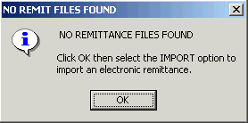
- Click OK.

Medicare Remit Easy Print opens with Import ready:
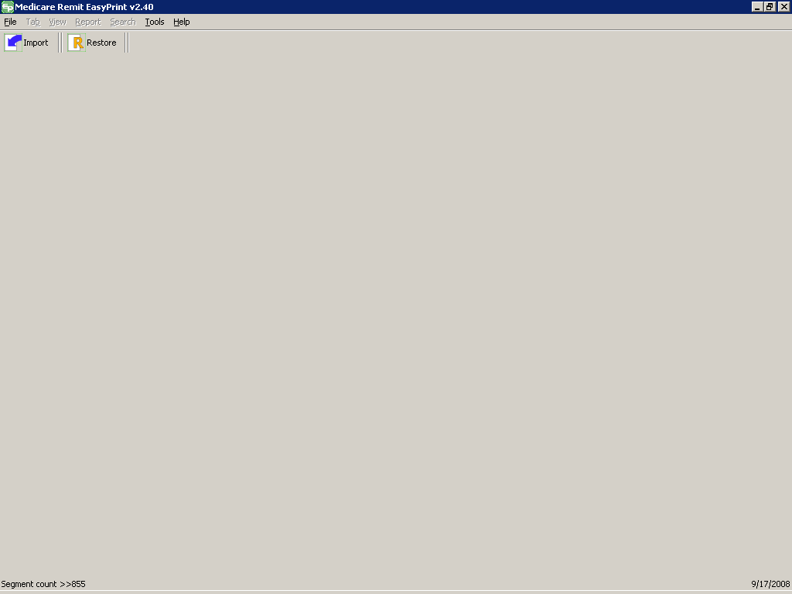
- Click Import.
A file dialog window opens permitting you to select the HIPAA 835 file to import.
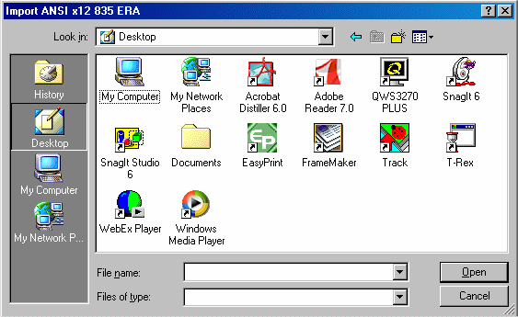
- Select the HIPAA 835 file that you want to import by double-clicking it.
Medicare Remit Easy Print starts the import to let you know that it is importing:

After the import finishes, the Remittance Advice List window appears.
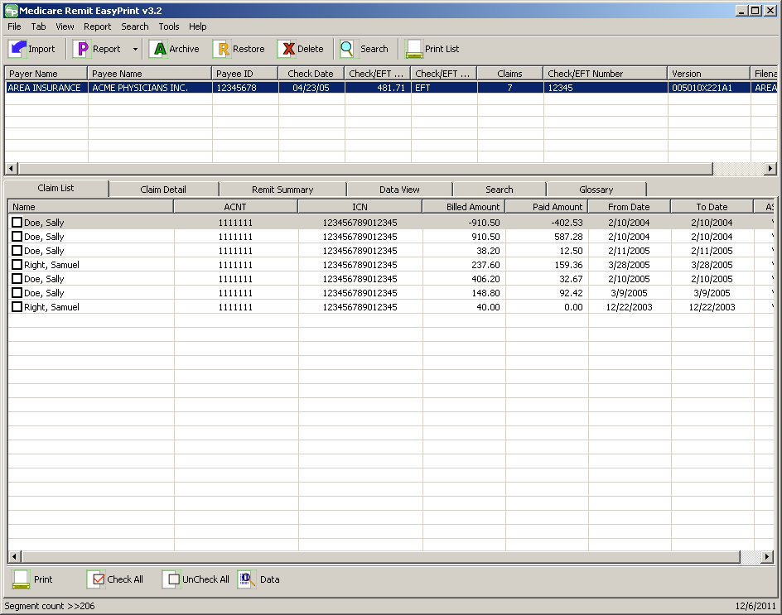

Locating MREP and MREP File Locations on Your PC/Network

Locating the MREP Application on Your PC/Network – Icon Available
- With your mouse, right click the icon on your desktop.

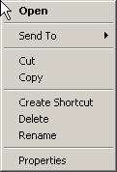
- Go to Properties, Shortcut, Start in and you see the directory where the Medicare Remit Easy Print directory is located.
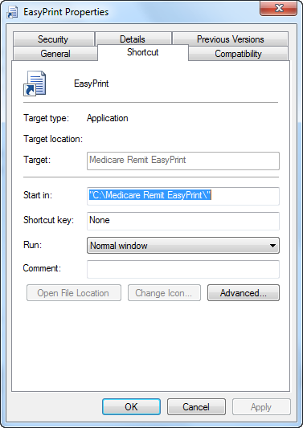

Locating the MREP Application on Your PC/Network – Icon not Available
- Click the Start menu.
- Select the ‘Search’ function.
- Select ‘For Files or Folders’.
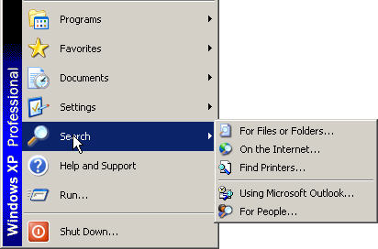
- Select ‘All files and folders’.
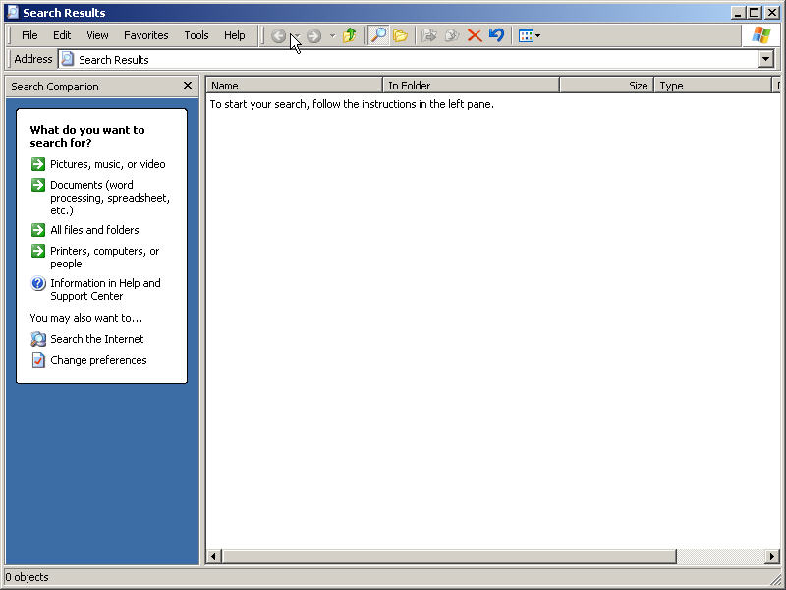
- Type ‘Medicare Remit Easy Print’ or the name you saved your MREP software under in ‘All files and folders’.
- Select ‘My Computer’ from the ‘Look In’ drop-down box.
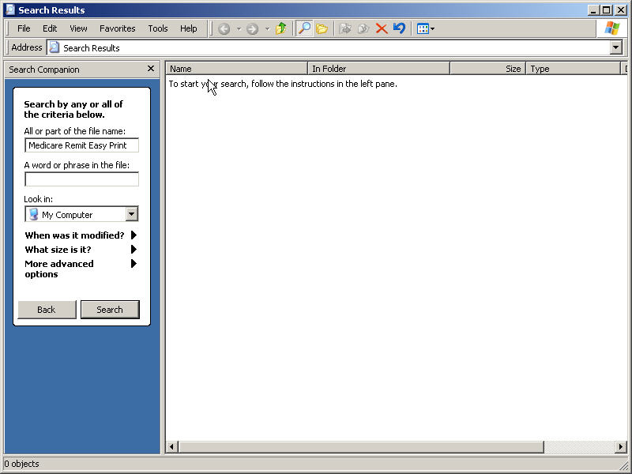
- Click Search.

Identifying Easy Print File Locations
This tool contains the current path to folders containing the files that Medicare Remit Easy Print uses. In most cases, these paths never need updating. But, in certain situations, the user may want to override the default locations of these folders.
- To identify the necessary files/resources that Medicare Remit Easy Print is using, select Path Name Editor from the Tools menu.
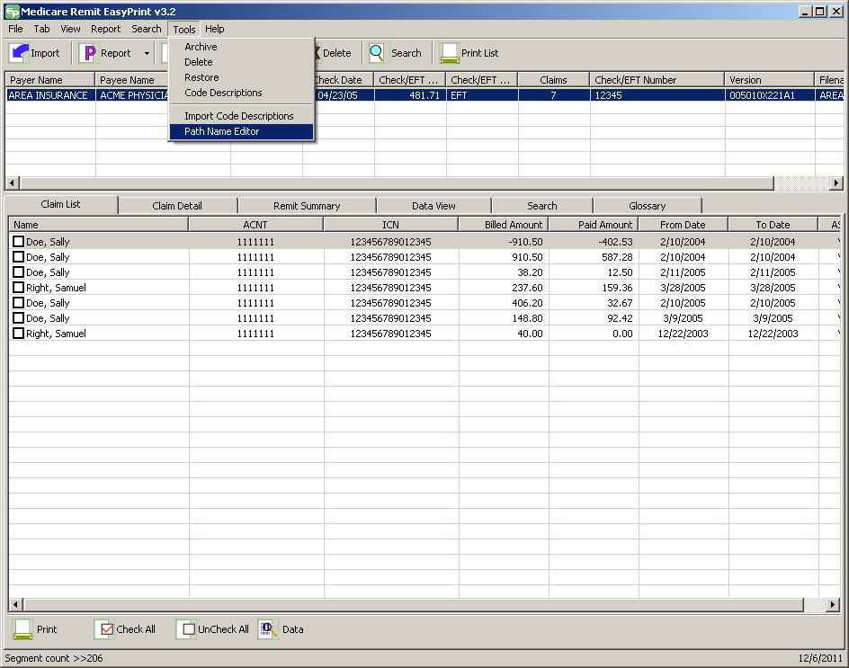
- The folder locations window appears showing the current folder location settings.
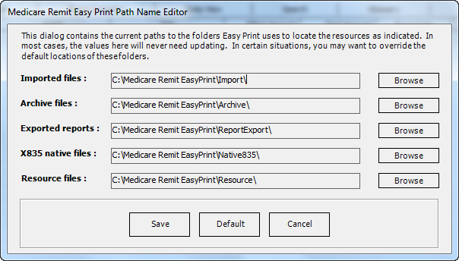
The Imported files: folder contains those files once the native 835 files have been imported into Medicare Remit Easy Print.
The Archive files: folder contains those files that have been archived from Medicare Remit Easy Print.
The Exported reports: folder contains those report files where the user chose to export the reports rather than printing them.
The X835 native files: folder contains the native 835 files that are imported into Medicare Remit Easy Print.
Note: When an issue is reported and the GDIT MREP Team requests the file sent for further investigation, this is the type of file that needs to be sent. The file has a “.txt” extension.
Identify the file/remittance advice in question or causing an issue.
For the provider/supplier community, send a copy of this file to your contractor and your contractor should send the same file to the GDIT MREP Team.
The Resource files: folder contains the necessary internal files (004010X091A1.FLD or 005010x221A1.FLD and loop.str) for Medicare Remit Easy Print to run. The Codes.ini file is also in this folder, but it is not required for Medicare Remit Easy Print to run. (Note: The Codes.ini file contains the descriptions of the CARCs, RARCs, Group Codes, and Business Scenarios. If it is not present, you receive a generic default message.)
Buttons
 Save changes made to the folders
 Reset the values for the files back to what they were when the Medicare Remit Easy Print application was initially installed
 Exit the Medicare Remit Easy Print Folder Locations display box without saving changes

Uninstalling Medicare Remit EasyPrint
- Navigate to the Windows Control Panel Add/Remove Programs.
  - From the taskbar, click Start > Control Panel.
  - The Control Panel window opens.
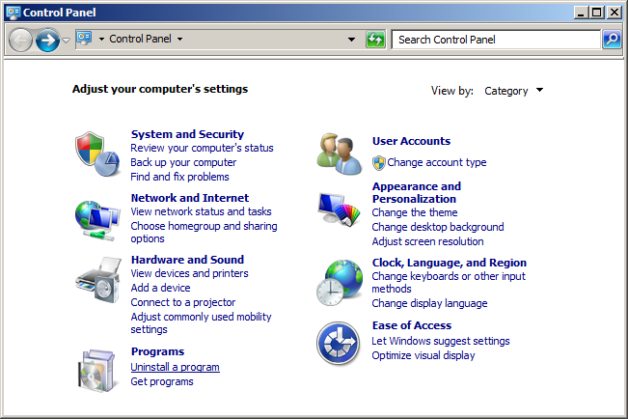
Windows 7 Control Panel
- Remove the Medicare Remit Easy Print Application.
  - Click Programs.
  - Click Programs and Features.
  - Select Medicare Remit Easy Print from the resulting list.
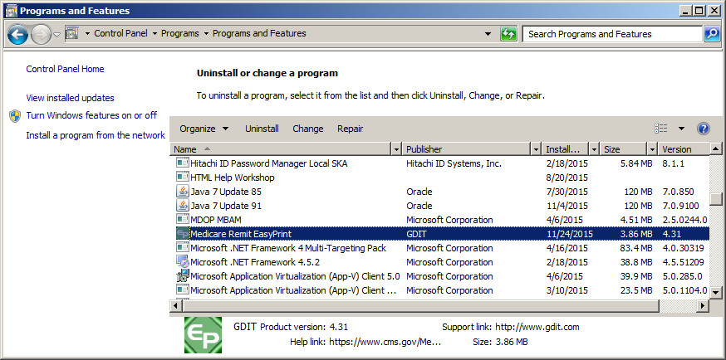
  - Click Remove, and then click Yes on the confirmation dialog.

The Uninstall process is complete!

Online Help System
The Medicare Remit Easy Print (MREP) Help online system allows you to look up information about MREP from MREP itself instead of referring to the Medicare Remit Easy Print User Guide. The online Help system is geared to the day-to-day tasks in MREP. It does not include information regarding the technical aspects of installing or running MREP on a PC or network.

How to Access the Online Help System
- Open Medicare Remit Easy Print by double-clicking the Medicare Remit Easy Print icon .
The Medicare Remit Easy Print Claim List tab opens.
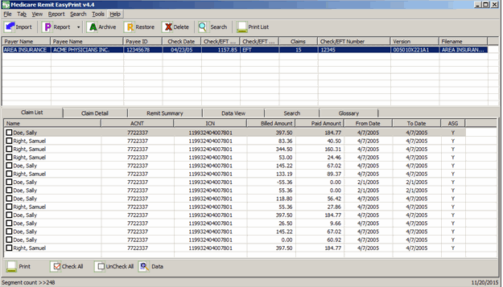
- Click Help.
Medicare Remit Easy Print opens the Medicare Remit Easy Print Help window and displays the introduction.
Note: Be sure that the Medicare Easy Print Help dialog box appears in the Contents tab in the left frame of the window.
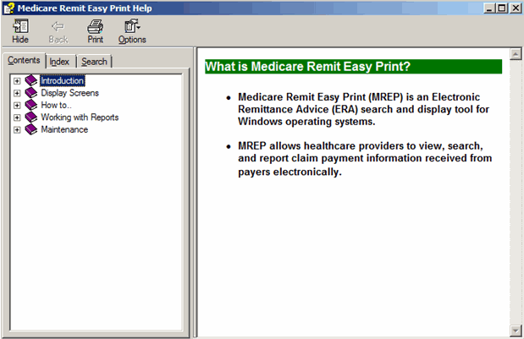

How to Use the Contents Tab
- To see what’s inside a book, click the + sign.
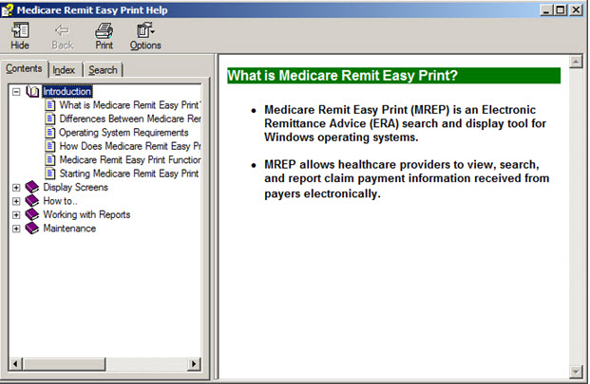
- Click a topic to display the topic.
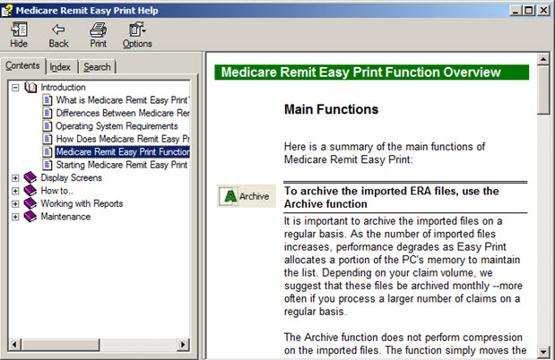
At this point, you can:
Print the topic Click 
View Options Click 
Return to the previous view Click 
Hide the tab Click 

How to Use the Index Tab
- Click the Index tab.
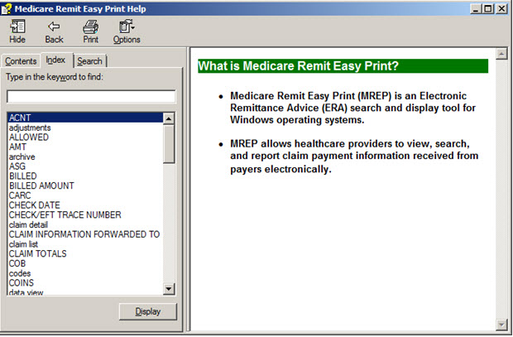
- Type a keyword to find.
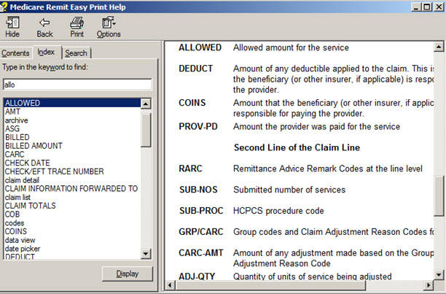
- Select a keyword by double clicking it or click the display.
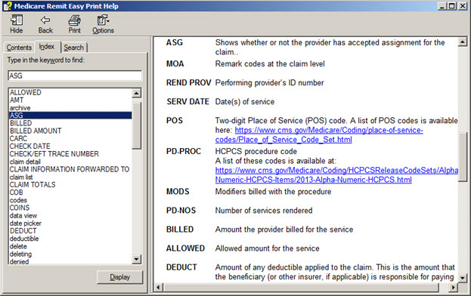

How to Use the Search Tab
- Click the Search tab.
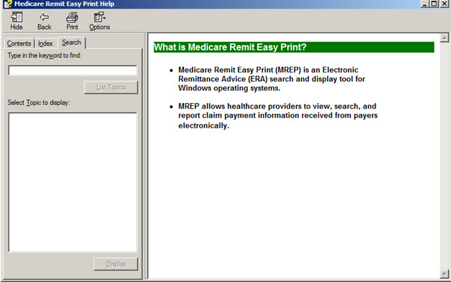
- Type a keyword to find, then click List Topics or type Alt + L.
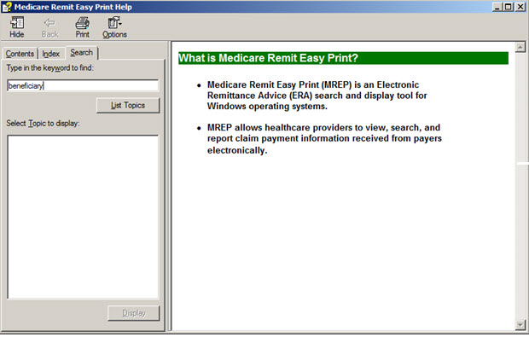
- Once the list of topics appears, double click the one you want.
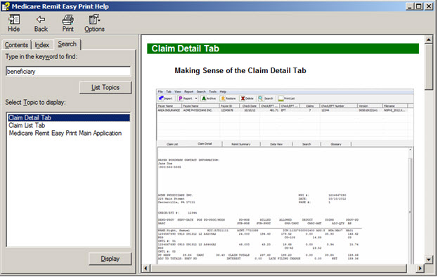

How to Close the Medicare Remit Easy Print Help Window
Click Close Window or type Alt + F4.

Importing HIPAA 835 files
The first time that you start Medicare Remit Easy Print, you must import an HIPAA 835 file.
For the procedure for the first import, see Step 1 of How to Start Medicare Remit Easy Print.

The first time you start Medicare Remit Easy Print, or when you don’t have any Remittance files in the Import folder you see the “No Remittance Files Found” dialog. Click or select OK to close the dialog.

Before You Import the HIPAA 835 File
Before you import an HIPAA 835 file, you must:
  - Install the Medicare Remit Easy Print program. (See PC Installations or Network Installations)
  - To determine the location of the HIPAA 835 folder or where your HIPAA 835 files are stored, complete Step 4 of the Pre-Installation Checklist for Installation on a PC.

Import File Name Format
When you import the HIPAA 835 file, Medicare Remit Easy Print makes a copy of it, renames it, and stores it in the Import file folder.
The file-naming format is as follows:
PPPPPPPPPPPPPPPPPPPPPPPPPPPPP Payer Name – 30 bytes maximum
CCCCCCCCCCCCCCC Check/EFT # – 15 bytes maximum
If a file has been imported successfully and you attempt to import the same file, an error record is written to the Import Exception Summary Window/Report and the file is not imported into the MREP application. Importing a file format other than HIPAA 835v5010A1 or 835v4010A1, or a non-compliant version of a HIPAA 835-formatted file also writes a record to the Import Exception Summary window/report and the file is not imported into the MREP application.
Note: With the release of MREP v2.9 (April 2011), the only acceptable versions of the HIPAA 835 file that can be imported into MREP are 835v5010A1 and 835v4010A1.

How to Import the HIPAA 835 File
- Open Medicare Remit Easy Print by double-clicking the Medicare Remit Easy Print icon.
The Medicare Remit Easy Print Claim List tab opens.
- Click Import or go to the File menu option and select Import.
Medicare Remit Easy Print opens a window for you to select the HIPAA 835 file to import:
- Select the HIPAA 835 file that you want to import by double-clicking it
Medicare Remit Easy Print starts the import and lets you know that it is importing:
After the import finishes, the MREP Remittance Advice List window appears.
At this point, you can:
Work with the MREP Remittance Advices See Working with MREP Remittance Advices

Work with Reports See Working with Reports
Note: Medicare Remit Easy Print reformats and saves a copy of the HIPAA 835 file. This copy is the Import file. If you import the same HIPAA 835 file more than once, Medicare Remit Easy Print bypasses the duplicate file and displays the Import Exception Summary Report indicating duplicate remittances were detected.
For information about making sense of the Import file name, see Import File Name Format.

How to Automatically Import the HIPAA 835 File
- Close Medicare Remit Easy Print. Right click on the Easy Print icon and click Properties. The EasyPrint.exe Properties window appears.
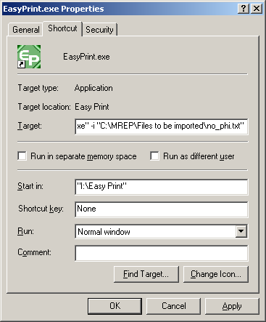
Note: The values in the various fields vary for each MREP user.
- The Target: value needs to be modified to indicate the location of the files that are to be imported. The user must enter a space after the last double quote, the value of –I or –i (not case sensitive), followed by another space and the pathname. The pathname must be in double quotes. For example, "I:\Easy Print\EasyPrint.exe" –i "C:\MREP\Files to be imported\no_phi.txt"

- To save the changes you made to the Target: value, you must click Apply.
- Once you click Apply, then you must click OK. The Properties window disappears.
- You can restart the MREP software.
Notes:
- If the user updates the Target field with a file path that does not exist, a message dialog appears stating the target file does not exist. Once the user chooses to close this window by clicking OK, the MREP software continues to run with the files that have already been imported.
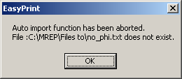
- Each time that the MREP software is invoked, it always accesses the import pathname to attempt to import the data that is contained in the specified file.
- When a duplicate remit file or a file with an invalid data format (not 835v4010A1 or 835v5010A1) is encountered, the Import Exception Summary window appears. The user can choose to Print or Close this window. Once the user chooses to close this window, the MREP software continues to run with files that have already been imported.

What to Do with an Import Error Message
There are two error messages that you may see:
For this error message: You need to:
Invalid File Format Select the correct HIPAA 835 file to import.
You have either selected an ERA not in a HIPAA 835 format or an ERA that is a HIPAA 835 with invalid delimiters. If you continue to receive this error, contact your contractor.
Path / File Access Error Check with your network/PC administrator
You need to have read/write access rights to the Medicare Remit Easy Print directory.

Import Exception Summary Window/Report
The Import Exception Summary window/report helps to identify duplicate files, file formats other than HIPAA 835v5010A1 or HIPAA 835v4010A1, non-compliant HIPAA 835-formatted files, and prevents the posting of “junk” files to the import folder. If any of the scenarios that are described above are encountered while attempting to import files to the MREP application, an Import Exception Summary dialog displays a list of invalid files by Payee and Check/EFT #, in addition to a brief description of the issue encountered.
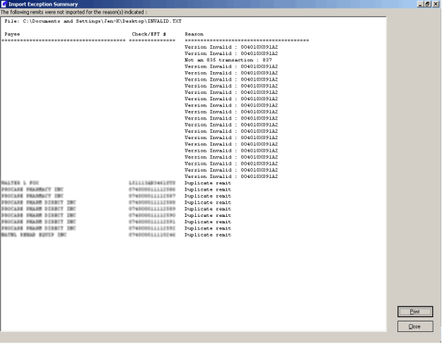

You have the option of closing the window or printing the Import Exception Summary. If you choose to print the Import Exception Summary report, the window does not close automatically once the report prints. You need to close the window using Close or “X-ing” out (top right corner of the Import Exception Summary window). The printing functionality for the Import Exception Summary report follows the existing printing functionality within MREP. Please note that if the window is closed prior to printing the report, the list of import error(s) is lost. To eliminate the need for file space management, a decision was made to not save the MREP Import Exception errors. To recreate the Import Exception Summary window, the files need to be imported again.
The Import Exception Summary window and report contains three columns of information.
- The first column of information is entitled “Payee”. Depending on what type of error is encountered during the import process, this field could contain data or spaces. The maximum number of bytes of data that can appear is 40.
- The second column of information is entitled “Check/EFT #”. Depending on what type of error is encountered during the import process, this field could contain data or spaces. The maximum number of bytes of data that can appear is 15.
- The third column of information is entitled “Reason”. Depending on what type of error that is encountered during the import process, there is the possibility of three different messages appearing.
Prior to the three columns of data, the Import Exception Summary window and report contains a heading with the title “File:” The information following the “File:” heading is the location and name of the file that the attempt is being made to import into the MREP application.
When the Import Exception Summary report prints, the printed version contains an additional heading prior the “File:” heading. It is the first heading on the report. On the left side of the page, the heading displays “Import Exception Summary”. In the center of the page, the heading displays the date and time stamp when the summary report was printed. The format of the date is MM/DD/CCYY. Please note that the leading zero in the month and day do not appear – for example: 2/15/2018. The format of the time is HH:MM:SS XX (XX represents AM or PM). On the right side of the page, the heading displays the version of the MREP application that is being used (for example: Easy Print v4.61).

Working with MREP Remittance Advices

How to View a List of Claims for an MREP Remittance Advice
- Open Medicare Remit Easy Print by double-clicking the Medicare Remit Easy Print icon .
The Medicare Remit Easy Print Claim List tab opens.
- Select the Remittance Advice by clicking it.
Medicare Remit Easy Print highlights the Remittance Advice and lists the associated claims as show in the following image.
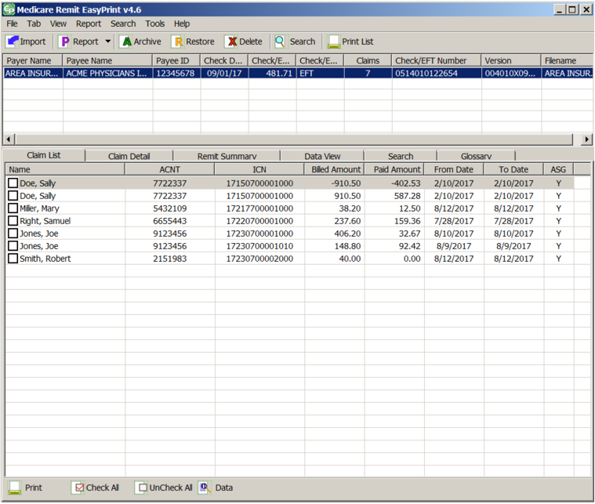
Note: Some screen reading applications may not be able to read all of the values on the claim list tab. Function key F1 displays an accessibility informational message allowing the screen reading application to recite the field names and values displayed in the listview for the highlighted claim. Please note the Patient’s Name appears the Last Name first, followed by a comma and then the First Name:
At this point, you can:
Find out more about this tab See page Making Sense of the Claim List Tab
Print the list Click or go to the Tab menu option and select Print Claim List, or type Alt + B + P.
For more info, see How to Print a List of Claims.
View claim details Click or go to the View menu option and select Claim Detail
For more info, see How to View the Detail for a Claim

View a Summary for the Remittance Advice Click or go to the View menu option and select Remit Summary
For more info, see How to View the Total Amounts for a Remittance Advice.
View the data that feeds the Remittance Advice Click or go to the View menu option and select Data View
For more info, see Making Sense of the Data View Tab.
Search Click or go to the View menu option and select Search
For more info, see How to Search Payment Information.
View the CARCs, RARCs, Group Codes, and
Business Scenarios for the Remittance Advice Click or go to the View menu option and select Glossary.
For more info, see Making Sense of the Glossary Tab.

How to View the Detail for a Claim
- Open Medicare Remit Easy Print by double-clicking the Medicare Remit Easy Print icon .
The Medicare Remit Easy Print Claim List tab opens.
- Select the Remittance Advice by clicking it.
Medicare Remit Easy Print highlights the Remittance Advice and lists the claims.

- Check the checkbox next to the claim(s) that you want to see detail. Detailed information only appears for claims that are checked.
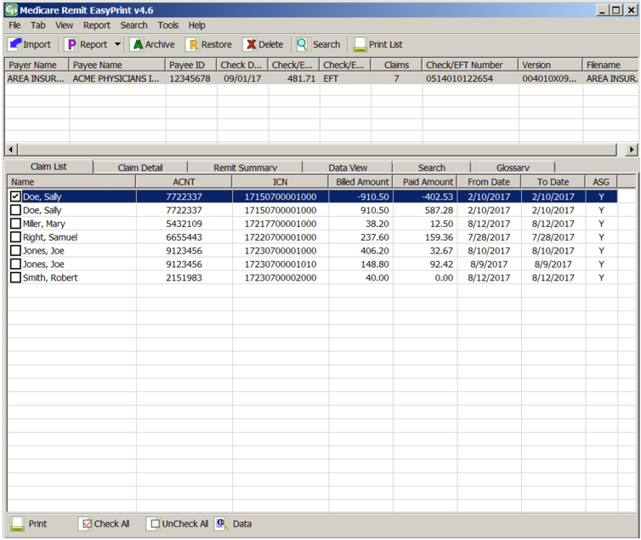

- Click the Claim Detail tab.
The detail appears for the claim you selected:
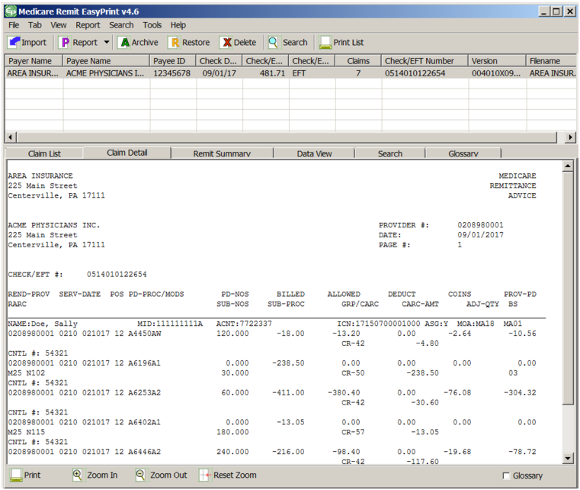
Find out more about this tab See page Making Sense of the Claim Detail.
Print the detail Click Print, or go to the Tab menu option and select Print Claim Detail, or type Alt + B + P.
For more info, see How to Print the Detail for a Claim.
Return to the Claim List Click the claim list tab or go to the View menu option and select Claim List.
For more info, see How to View a List of Claims for an MREP Remittance Advice.

View a Summary for the Remittance Advice Click the summary tab or go to the View menu option and select Remit Summary.
For more info, see How to View the Total Amounts for a Remittance Advice.
View the data that feeds the Remittance Advice Click the Data View tab or go to the View menu option and select Data View.
For more info, see Making Sense of the Data View Tab.
Search Click the Search Tab or go to the View menu option and Search.
For more info, see How to Search Payment Information.
View the CARCs, RARCs, Group Codes, and
Business Scenarios for the Remittance Advice Click the Glossary Tab or go to the View menu option and select Glossary.
For more info, see Making Sense of the Glossary Tab.
Option to print or suppress the printing of A check box with the word Glossary appears in the
the glossary of CARCs and RARCs for the lower right side of the Claim Detail tab. When this
Remittance Advice (not available for check box is checked, the glossary of CARCs and
Remittance Advices printed from the RARCs involved with a particular MREP
menu bar or toolbar) Remittance Advice prints on a separate page. When the check box is not checked, the glossary of CARCs and RARCs involved with a particular MREP Remittance Advice does not print.
You also have the option via the Tab menu option to show or not show the glossary of CARCs and RARCs involved with the MREP Remittance Advice.

How to View the Total Amounts for a Remittance Advice
- Open Medicare Remit Easy Print by double-clicking the Medicare Remit Easy Print icon.
The Medicare Remit Easy Print Claim List tab opens.
- Select the Remittance Advice by clicking it.
Medicare Remit Easy Print highlights the Remittance Advice and lists the claims below.
- Click the Remit Summary Tab or type Alt + V + S.
Medicare Remit Easy Print displays the totals, for example
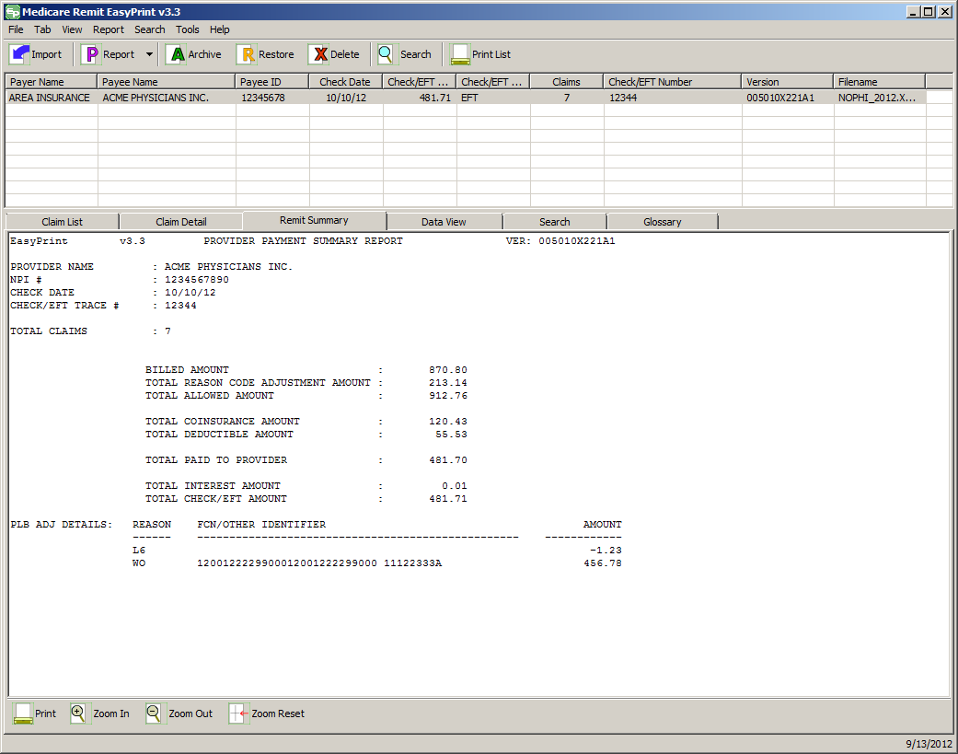
At this point, you can:
Find out more about this tab See Making Sense of the Remit Summary Tab.

Print the summary Click Print or go to the Tab menu option and select Print Claim Detail or type Alt + B + P.
View claim details Click the Claim Detail Tab or go to the View menu option and select Claim Detail
For more info, see How to View the Detail for a Claim.

Return to the Claim List Click the Claim List tab or go to the View menu option and select Claim List
For more info, see How to View a List of Claims for an MREP Remittance Advice.

View the data that feeds the Remittance Advice Click the Data View tab or go to the View menu option and select Data View
For more info, see Making Sense of the Data View Tab.
Search Click the Search tab or go to the View menu option and select Search
For more info, see How to Search Payment Information.
View the CARCs, RARCs, Group Codes, and Click the Glossary tab or go
Business Scenarios for the Remittance Advice to the View menu option and select Glossary
For more info, see Making Sense of the Glossary Tab.

How to View the Data in the Import File
- Open Medicare Remit Easy Print by double-clicking the Medicare Remit Easy Print icon.
The Medicare Remit Easy Print Claim List tab opens.
- Select the Remittance Advice by clicking it.
Medicare Remit Easy Print highlights the Remittance Advice and lists the claims.
- Click the Data View Tab or type Alt + VV.
Medicare Remit Easy Print displays the file format:
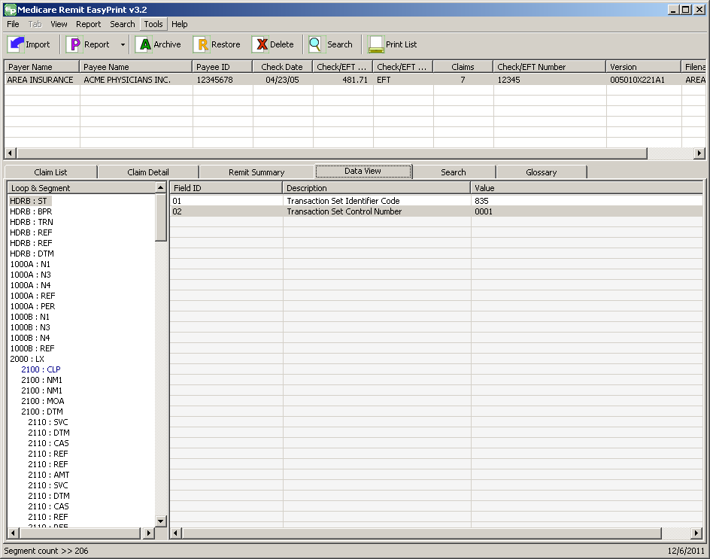
At this point, you can:
Find out more about this window See page Making Sense of the Data View Tab.
View claim details Click the Claim Detail tab or, go to the View menu option and select Claim Detail.
For more info, see How to View the Detail for a Claim.
Return to the Claim List Click the Claim List tab or go to the View menu option and select Claim List.
For more info, see How to View a List of Claims for an MREP Remittance Advice.
View a Summary for the Remittance Advice Click the Summary tab or, go to the View menu option and select Remit Summary.
For more info, see How to View the Total Amounts for a Remittance Advice.
Search Select the Search tab or, go to the View menu option and select Search.
For more info, see How to Search Payment Information.
View the CARCs and RARCs for the Select the Glossary tab
Remittance Advice or, go to the View menu option and select Glossary.
For more info, see Making Sense of the Glossary Tab.

How to View the CARC and RARC Codes
- Open Medicare Remit Easy Print by double-clicking the Medicare Remit Easy Print icon.
The Medicare Remit Easy Print Claim List tab opens.
- Select the Remittance Advice by clicking it.
Medicare Remit Easy Print highlights the Remittance Advice and lists the claims below.
- Click the Glossary Tab or type Alt +V + G.
Medicare Remit Easy Print shows the Reason and Remark codes for the Remittance Advice:
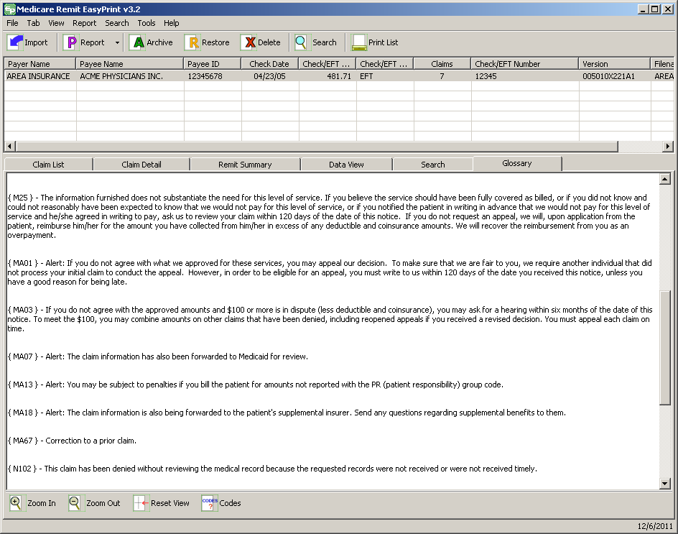

At this point, you can:
Find out more about this tab See page Making Sense of the Glossary Tab
View claim details Click the Claim Detail tab or go to the View menu option and select Claim Detail.
For more info, see How to View the Detail for a Claim.
Return to the Claim List Click the Claim List tab or go to the View menu option and select Claim List.
For more info, see How to View a List of Claims for an MREP Remittance Advice.
View a Summary for the Remittance Click the Summary tab or go to
Advice the View menu option and select Remit Summary.
For more info, see How to View the Total Amounts for a Remittance Advice on page 91.
View the data that feeds the Select the Data View tab or go
Remittance Advice to the View menu option and select Data View.
For more info, see Making Sense of the Data View Tab.
Search Select the Search tab or go to the View menu option and select Search.
For more info, see How to Search Payment Information.
View the CARCs and RARCs for Click Codes at the
the Remittance Advice bottom of the tab or type Alt + B + C.
For more information, see How to View the CARC and RARC Codes

How to Look up a CARC/RARC Code, Group Code, or CORE Business Scenario
  - Open Medicare Remit Easy Print by double-clicking .
The Medicare Remit Easy Print Claim List tab opens.
- On the menu Select Tools > Code Descriptions.
The Code Descriptions window opens.
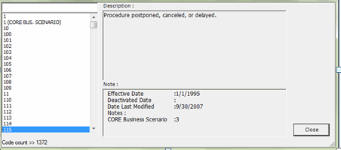

How to Update (Import) the CARC/RARC Codes, Group Codes, and CORE Business Scenarios
At a minimum, the ANSI Claim Adjustment Reason Code (CARC) and Remittance Advice Remark Code (RARC) file requires an update three times a year. When the list of codes is updated per Washington Publishing Company, GDIT provides an updated file on the VMS ETS website for the contractors and CMS provides a link to the updated file on the CMS website for the provider/supplier community. When the user finds it necessary to import this updated file into MREP, follow these instructions:
- Access the list of the latest codes from the VMS ETS or CMS website.
- Save the list of latest codes so they are easily accessible.
Note: The file name must be saved as Codes.ini for MREP to successfully find the code file.
- Select Import Code Descriptions from the Tools menu.
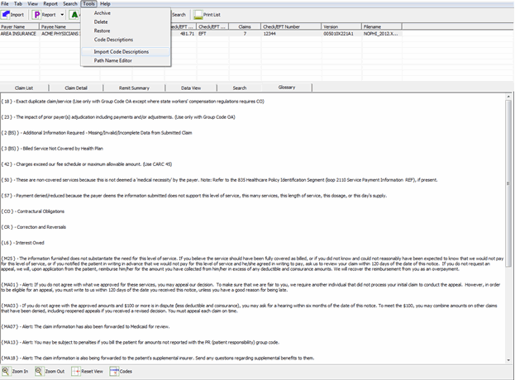

A dialog window appears asking to confirm the code import.
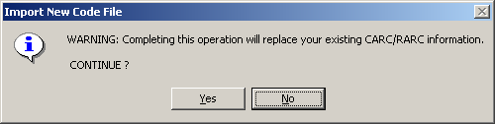
If you select NO, the dialog box disappears and no updates are made to MREP. If you select YES, another file dialog box appears.
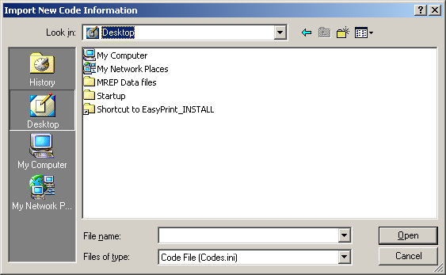
- Navigate to the folder or area where you saved the file under step 2. Select the Codes.ini file and then click Open.
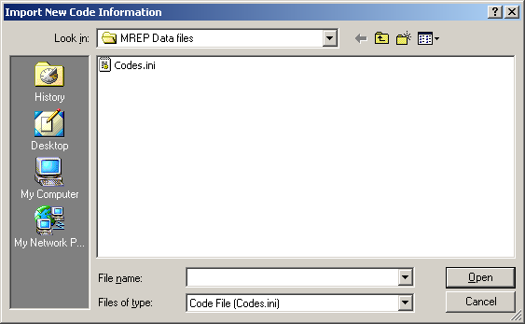
- After you press Open, a dialog displays confirming the code import was successful. Click, or select OK to close the dialog.
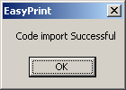
Click OK.
- The latest list of CARC/RARCs exists in the MREP application. To verify that the latest version exists, select Code Descriptions from the Tools menu.

- The Easy Print – Reason/Remark/Group Codes dialog box appears.
Note: The Easy Print – Reason/Remark/Group Codes dialog box includes the date of the latest version of the code list.
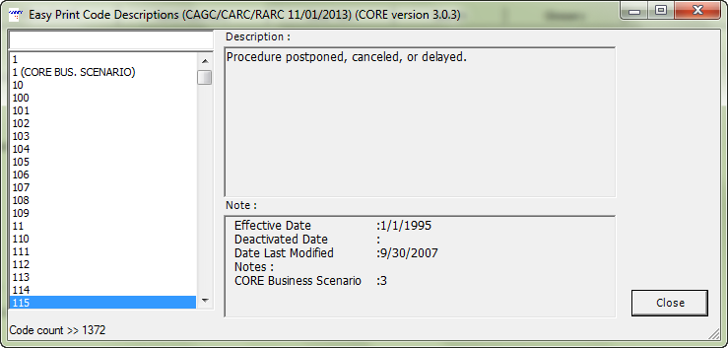

How to Print a List of Claims
- View the list of claims.
For the steps to follow, see How to View a List of Claims for an MREP Remittance Advice.
- Click Print at the bottom of the tab or type Alt + B + P.
The Print remit listing window opens.
- Print the detail listing in one of the following ways:
  - From the Print remit listing window, click Print to print the detail without previewing it.
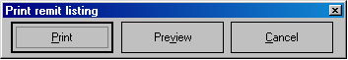
The Print dialog opens.
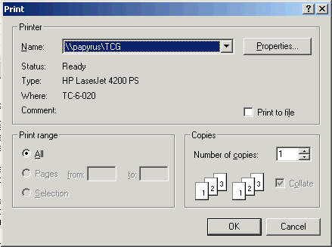
If you need to change the properties, click Properties and make changes as necessary.
Click OK. Medicare Remit Easy Print prints the detail at your default printer.
  - From the Print remit listing window, click Preview to view a preview of the printed page before printing.
The Print Preview window opens.
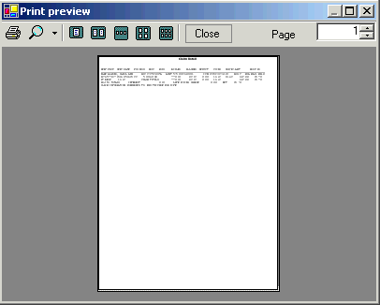
Click the Printer at the top of the window.
Medicare Remit Easy Print prints the detail at your default printer.
At this point, you can:
View claim details Click the Claim Detail tab or go to the View menu option and select Claim Detail
For more info, see How to View the Detail for a Claim.

Search Click the Search tab or go to the View menu option and select Search
For more info, see How to Search Payment Information.
View a Summary for the Remittance Advice Click the Summary tab or go to the View menu option and select Remit Summary
For more info, see How to View the Total Amounts for a Remittance Advice
View the data that feeds the Remittance Advice Click the Data View tab or go to the View menu option and select Data View
For more info, see Making Sense of the Data View Tab.
View the CARCs, RARCs, Group Codes, and Click the Glossary tab
Business Scenarios for the Remittance Advice or go to the View menu option and select Glossary
For more info, see How to View the CARC and RARC Codes.

How to Print the Detail for a Claim
- View the detail for the claim.
For the steps to follow, see How to View the Detail for a Claim.

- Click print at the bottom of the tab, or type Alt + B + P. The Print remit listing window opens.
- Print the detail listing in one of the following ways:
  - Click Print to print the detail without previewing it.
The Print dialog box opens.
If you need to change the properties, click Properties and make changes as necessary.
Click OK. Medicare Remit Easy Print prints the detail at your default printer.
  - Click Preview to view a preview of the printed page before printing.
The Print Preview window opens.
Click Printer at the top of the window.
Medicare Remit Easy Print prints the detail at your default printer.

How to Print the Remittance Advice Summary
- View the Remittance Advice Summary.
For the steps to follow, see How to View the Total Amounts for a Remittance Advice.
- Click Print at the bottom of the tab, or type Alt + B + P.
The Print remit listing window opens.
- Print the detail listing in one of the following ways:
    - Click Print to print the detail without previewing it.
The Print dialog box opens.
If you need to change the properties, click Properties and make changes as necessary.
Click OK. Medicare Remit Easy Print prints the detail at your default printer.
    - Click Preview to view a preview of the printed page before printing.
The Print Preview window opens.
Click Printer at the top of the window.
Medicare Remit Easy Print prints the detail at your default printer.

Searching Payment Information
You can search by:
  - Adjusted Lines
  - Bene Account Number
  - Bene Last Name
  - CARC
  - COB Claims
  - Coinsurance Lines
  - Deductible Lines
  - Deductible/Coins Lines
  - Denied Lines
  - ICN
  - MID
  - MSP Claims
  - NDC
  - Non-COB Claims
  - Non-MSP Claims
  - Other Adjustments
  - Procedure Code
  - Rendering Provider Number
  - Service Date (range of dates in the format DD, DD/YY, MM, MM/DD, MM/DD/YY, MM/YY, or YY; forward slashes are not required when entering a value in the Value to Find field)

How to Search Payment Information
    - Open Medicare Remit Easy Print by double-clicking the Medicare Remit Easy Print icon.
The Medicare Remit Easy Print Claim List tab opens.
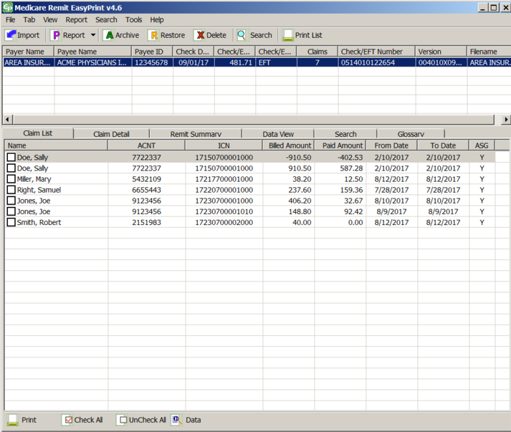

- Click Search or use the Search tab.
The Search tab opens.
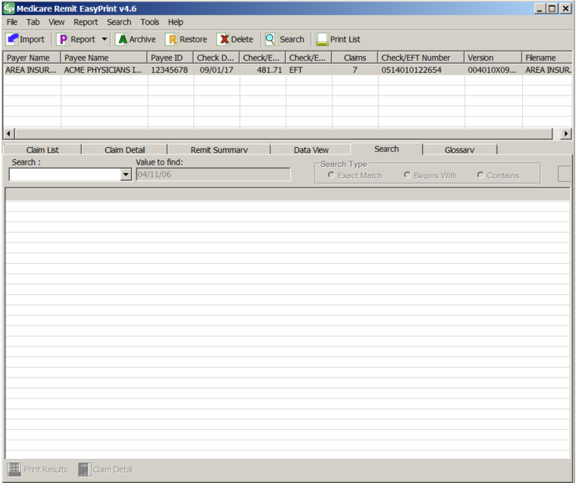

- Use the drop-down list to select a search field.
If applicable, enter the value to find. The Search tab includes three options for how to search the field (Exact Match, Begins With, or Contains).
To display the “searched” data, you must select one of the options before clicking Search. The Exact Match, Begins With, and Contains options are only available for the MID, ICN, Bene Account Number, Bene Last Name, NDC, Procedure Code and Rendering Provider fields.
If the Search: field is not one of these fields, the Exact Match, Begins With and Contains options are not available.
If you select one of the Service Date formats from the drop-down menu, you can:
  - Enter the date in the Value to find field
  - Use the drop-down list only to access the Calendar picker for the MM/DD/YY format only. Use the left and right arrows to select the month, and then click the date you want.
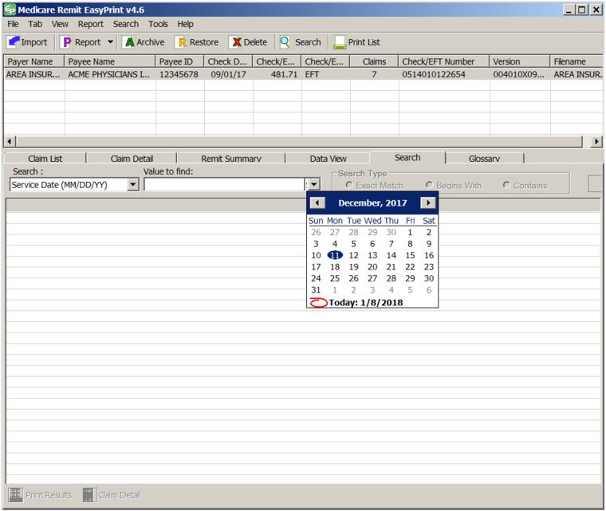
- Click the Search type to start the search.
Medicare Remit Easy Print returns all of the claim lines/info that match the search.
For example, imagine you needed to view all of Sally Doe’s claims. If the remit contains any claim lines with the name Doe, the Search Tab list view is updated with those claim lines matching the criteria.
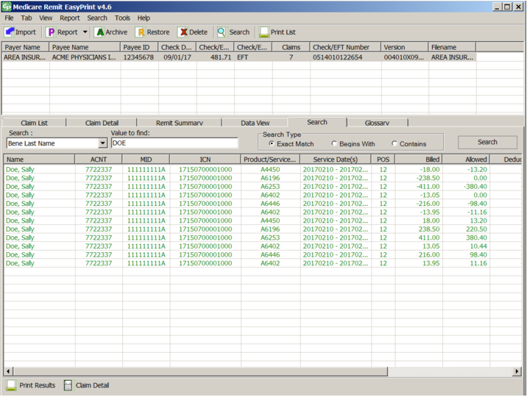

Making Sense of the Claim List Tab
For the procedure to view the claim list, see How to View a List of Claims for an MREP Remittance Advice.
The claim list tab displays a summary of all of the claims found within the selected remittance:
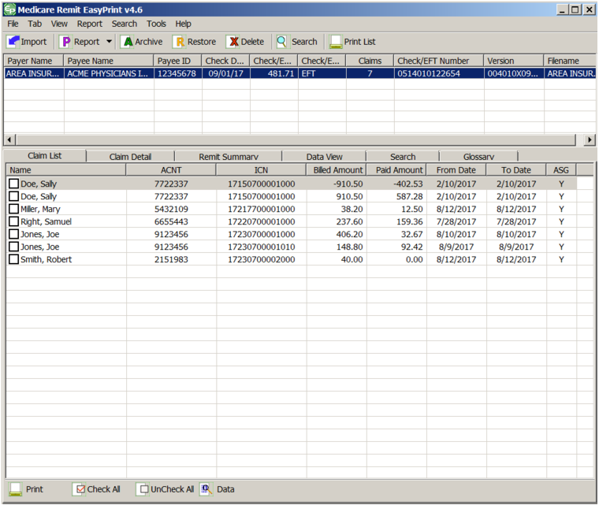
Name This is the name of the beneficiary that the claim was processed for. The name field is defined as Last Name followed by the First Name. A comma separates the two names.
ACNT This is any internal number assigned to the claim by the provider.
ICN This is the Internal Control Number (ICN), the unique number assigned to the claim when it is received by the contractor.
Billed Amount This is the total claim dollar billed amount.
Paid Amount This is the total claim provider billed amount.

From Date This is the earliest From Date of service on the claim.
To Date This is the latest To Date of service on the claim.
ASG This indicates whether or not the provider has accepted assignment for the claim.
Buttons
Print the list; or type Alt + B + P
 Select all of the claims; or type Alt + B + C
 Unselect all of the claims; or type Alt + B + U
View the data that feeds the remittance advice; or type Alt + V+ V

Display Claim(s)
Select claims in the claim list by clicking the checkbox for the corresponding claim. To display the selected claims, select Display Claim from the Tab dropdown list.
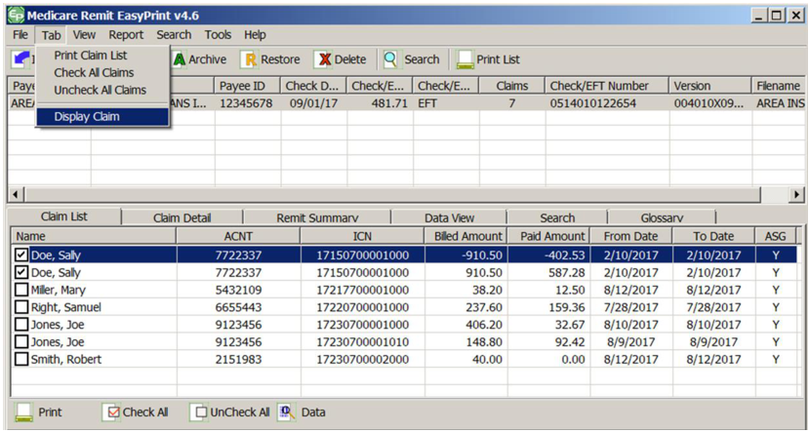

EasyPrint displays the claim(s) information in a vertical line-by-line format.
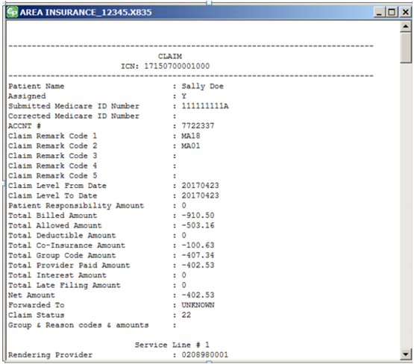
This format provides the claim data at a glance and allows screen reading software to interpret the data more easily.

Making Sense of the Claim Detail Tab
For the procedure to view claim detail, see How to View the Detail for a Claim.
The Claim Detail tab displays all the claim information for each claim(s) that has been checked on the Claim List tab.
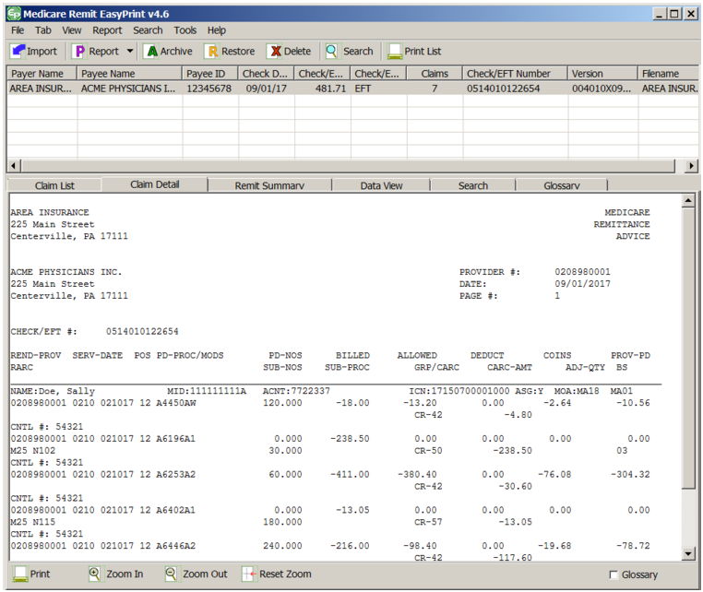

INFORMATION FOR THE CLAIM:
Note: This is an image of the lower part of the window.
First Line of Claim Line
NAME This is the name of the beneficiary for whom the claim was processed.
MID This is the Medicare Identification (MID) number of the beneficiary for whom the claim was processed. This could be a Health Insurance Claim (HIC) number or a Medicare Beneficiary Identification (MBI) number.
ACNT This is any internal number assigned to the claim by the provider.
ICN Internal Control Number (ICN); the unique number assigned to the claim when it is received by the contractor.
ASG Shows whether or not the provider has accepted assignment for the claim.
MOA Remark codes at the claim level.
REND-PROV Performing provider’s ID number.
SERV-DATE Date(s) of service.
POS Two-digit Place of Service (POS) code
A list of POS codes is available here: http://www.cms.gov/manuals/downloads/clm104c26.pdf
PD-PROC HCPCS procedure code
A list of these codes is available here: https://www.cms.gov/CLIA/downloads/Subject.to.CLIA.pdf
MODS Modifiers billed with the procedure.
PD-NOS Number of services rendered.
BILLED Amount the provider billed for the service.
ALLOWED Allowed amount for the service.
DEDUCT Amount of any deductible applied to the claim.
This is the amount that the beneficiary (or other insurer, if applicable) is responsible for paying the provider.
COINS Amount that the beneficiary (or other insurer, if applicable) is responsible for paying the provider.
PROV-PD Amount the provider was paid for the service.
Second Line of Claim Line
RARC Remittance Advice Remark Codes at the line level.
SUB-NOS Submitted number of services.
SUB-PROC HCPCS procedure code
GRP/CARC Group Codes and Claim Adjustment Reason Codes for the service line
CARC-AMT Amount of any adjustment made based on the Group and Claims Adjustment Reason Code
ADJ-QTY Quantity of units of service being adjusted
BS CORE-defined Business Scenarios associated with the Claim Adjustment Reason Code
CNTL # Line item control number.
HCPI Healthcare Policy Identification number
Totals
PT RESP Total amount that the beneficiary owes the provider for this claim
CARC Total amount of all claim adjustments on all service lines
CLAIM TOTALS Totals for all service-line level amounts:
BILLED
ALLOWED
DEDUCT
COINS
PROV-PD
ADJ TO TOTALS:
PREV PD Blank in Medicare Remit Easy Print
INTEREST Interest amount paid for claims processing time
LATE FILING CHARGE Late filing charge
NET Amount that Medicare owes the provider for this claim
CLAIM INFORMATION Appears when the claim is forwarded to a
FORWARDED TO: beneficiary’s supplemental insurer
CORRECTED PRIORITY Corrected priority payer name and/or id number
PAYER INFO:
OTHER CLAIM REL Additional information relevant to the adjudication
IDENTIFICATION: of the claim and a qualifier identifying the type of reference information
GLOSSARY Reason, Remark, Group codes, and Business Scenarios that are also shown on the Glossary tab
Buttons
Print the claim detail; or press Alt + B + P
Make the size of the type larger; or press Alt + B + I
Make the size of the type smaller; or press Alt + B + O
Reset the type to the original size; or press Alt + B + R
Check to see CARCs/RARCs and Business Scenarios with descriptions for the selected claims; or press Alt + B + S

Making Sense of the Remit Summary Tab
For the procedure to view the Remittance Advice detail, see How to View the Total Amounts for a Remittance Advice.
The Remit Summary Tab displays total dollar amounts, claim counts, and provider adjustment information if present in the selected remittance.
PROVIDER NAME Provider’s name
PROVIDER # Provider’s ID number
CHECK DATE Date of the check
CHECK /EFT TRACE NUMBER Tracking number for the check or EFT
TOTAL CLAIMS Total number of claims
BILLED AMOUNT Total billed amount
TOTAL REASON CODE Total adjustment amount.
ADJUSTMENT AMOUNT
TOTAL ALLOWED AMOUNT Total allowed amount
TOTAL COINSURANCE AMOUNT Total amount of coinsurance applied
TOTAL DEDUCTIBLE AMOUNT Total deductible amount
TOTAL PAID TO PROVIDER Total amount paid to provider.
TOTAL INTEREST AMOUNT Total amount of interest applied.
TOTAL CHECK /EFT AMOUNT Total amount of the check.
PLB ADJ DETAILS Remittance-level (PLB) adjustment
This field only appears if a remittance-level adjustment is present.
Buttons
Print the summary; or type Alt + B + P
Make the size of the type larger; or type Alt + B + I
Make the size of the type smaller; or type Alt + B + O
Reset the type to its original size; or type Alt + B + R

Making Sense of the Data View Tab
For the procedure to view the data, see How to View the Data in the Import File.
The Data View Tab displays the remittance fields as they are stored internally in MREP. The data are stored in what are referred to as Segments. Each segment contains a varying number of elements or fields.
The X12 835 5010A1 formats separate data into segments and loops. To understand how to read segments and loops, refer to the X12 835 Implementation Guide, which is available through the Washington Publishing Company at www.wpc-edi.com and the CMS Standard Companion Guide Transaction Information: Instructions related to the 835 Health Care Claim Payment/Advice based on ASC X12 Technical Report Type 3 (TR3), version 005010A1 https://www.cms.gov/medicare/billing/electronicbillingeditrans/downloads/5010a1835cg.pdf.

Making Sense of the Search Tab
For the procedure to view the data, see How to Search Payment Information.
The Search tab displays a summarized list of claim information that matches the criteria of the user’s search. The Name field’s format is the beneficiary’s Last Name, followed by a comma and then the First Name.
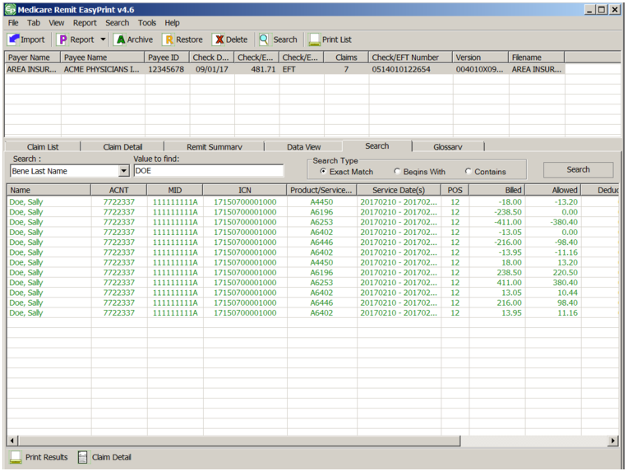

Buttons
 Print the list of claims from the search; or type Alt + B + P
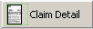 View details for all of the claims from the search; or type Alt + B + C

Making Sense of the Glossary Tab
For the procedure to view the data shown in the Glossary Tab see How to View the CARC and RARC Codes.
The Glossary tab displays the CAGC/CARC/RARC code and Business Scenario with descriptions for the selected remittance.
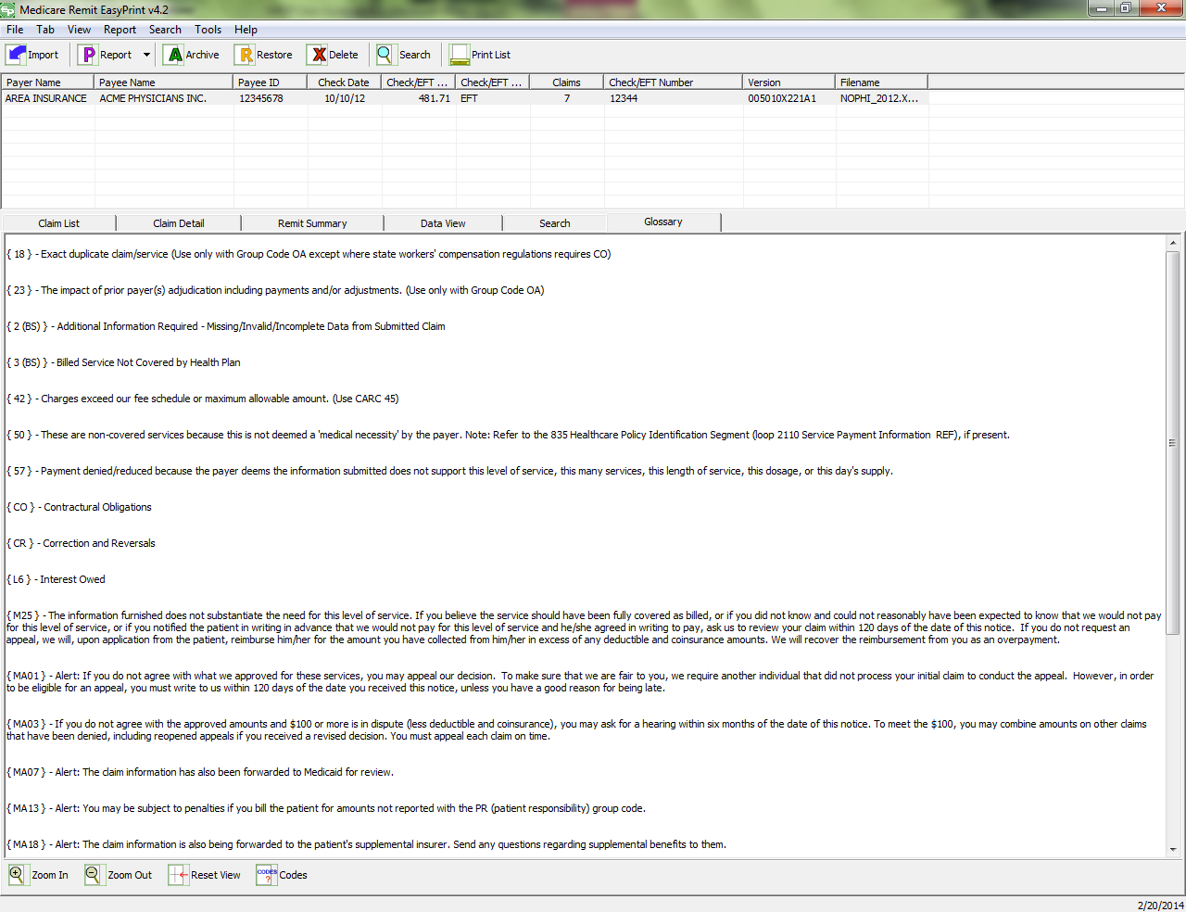
Buttons
Make the size of the type larger; or type Alt + B + I
Make the size of the type smaller; or type Alt + B + O
Reset the type to its original size; type Alt + B + R
Displays CARCs/RARCs and descriptions for the selected claims when checked; or type Alt + B + S

Working with Reports
Medicare Remit Easy Print provides 11 different reports:
  - Denied Service Lines
  - Adjusted Service Lines
  - Deductible Service Lines
  - Coinsurance Service Lines
  - Deductible/Coinsurance Service Lines
  - COB Claims Report
  - Non-COB Claims Report
  - MSP Claims Report
  - Non-MSP Claims Report
  - Other Adjustment Report
  - Entire Remittance

Making Sense of the Denied Service Lines Report
This report displays claim service lines that have an allowed amount equal to zero and are associated with a claim that does NOT have a claim status 22 (reversed claim). The report includes only the lines on the claim that meet these criteria.
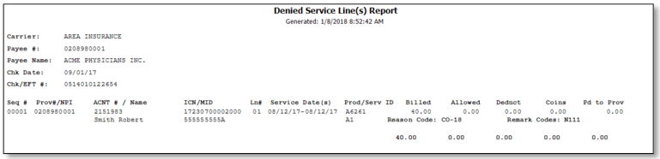

Making Sense of the Adjusted Service Lines Report
This report displays claims that have a status of 22 (reversed claim).
This report does NOT show the adjustment claim that reflects the corrected dollar amounts.
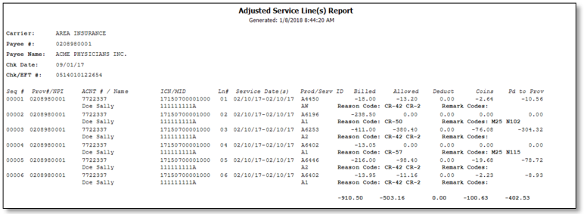

Making Sense of the Deductible Service Lines Report
This report shows claim service lines that have deductible amounts greater than zero, as well as those service lines with only deductible amounts greater than zero. It includes only the lines on the claim that meet these criteria.
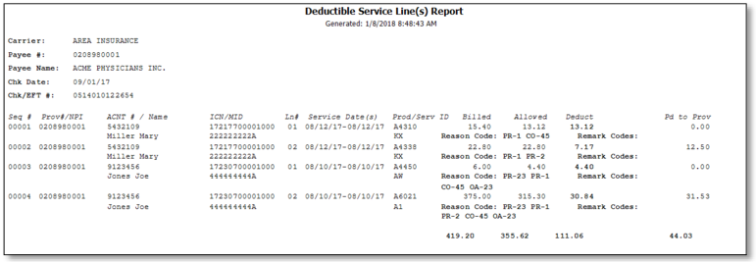

Making Sense of the Coinsurance Service Lines Report
This report shows claim service lines that have coinsurance amounts greater than zero, as well as those service lines with only coinsurance amounts greater than zero. It includes only the lines on the claim that meet these criteria.
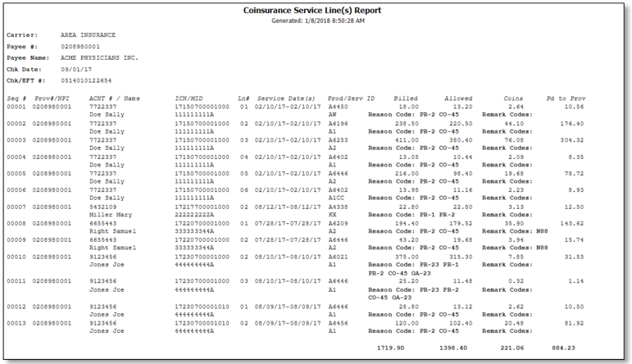

Making Sense of the Deductible/Coinsurance Service Lines Report
This report shows claim service lines that have both deductible and coinsurance amounts greater than zero, as well as those service lines with only coinsurance and deductible amounts greater than zero. It includes only the lines on the claim that meet these criteria.
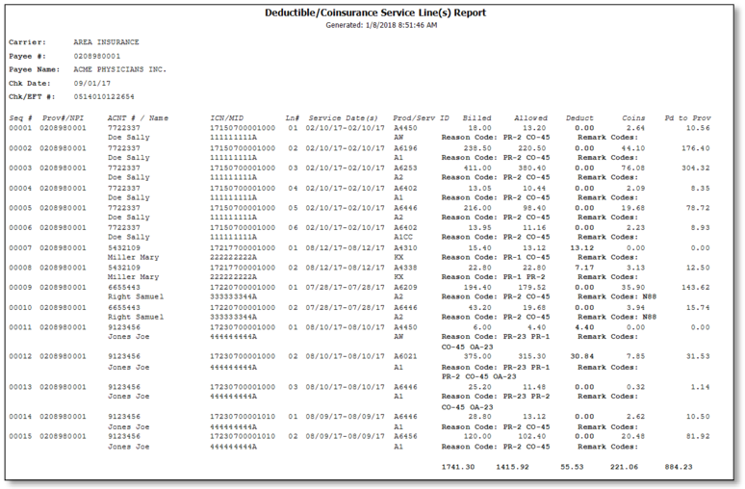

Making Sense of the COB Claims Report
This report shows those claims on the HIPAA 835v4010A1 or 835v5010A1 file that were crossed over. The requirement for crossover claims to print on the report is that the 2100 loop; CLP02 data field must contain one of the following values:
19 Processed as Primary, Forwarded to Additional Payer(s)
20 Processed as Secondary, Forwarded to Additional Payer(s)
- Processed as Tertiary, Forward to Additional Payer(s)
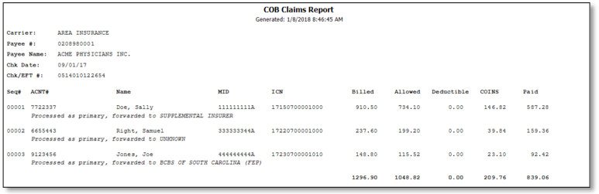

Making Sense of the Non-COB Claims Report
This report shows those claims on the HIPAA 835v4010A1 or 835v5010A1 file that did not cross over. The requirement for claims to print on the report is that the 2100.CLP02 data field does not contain one of the following values:
19 Processed as Primary, Forwarded to Additional Payer(s)
20 Processed as Secondary, Forwarded to Additional Payer(s)
- Processed as Tertiary, Forward to Additional Payer(s)
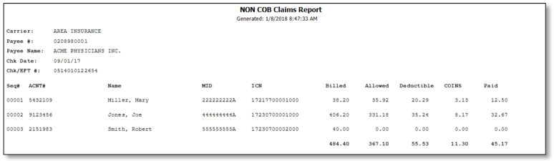

Making Sense of the MSP Claims Report
This report contains those claims, within a remittance, on the HIPAA 835v4010A1 or 835v5010A1 file that were processed by Medicare as secondary. The claims have a value of 2 (Processed as Secondary) or 20 (Processed as Secondary, Forwarded to Additional Payer(s)) in the 2100 loop, CLP02 data field.
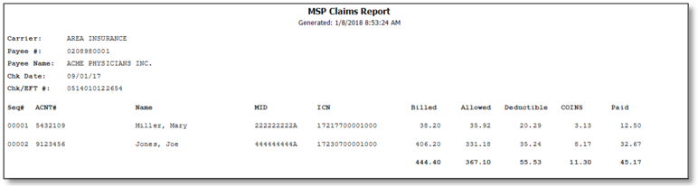

Making Sense of the Non-MSP Claims Report
This report contains those claims, within a remittance, on the HIPAA 835v4010A1 or 835v5010A1 file that were processed by Medicare as primary. The claims have a value of 1 (Processed as Primary) or 19 (Processed as Primary, Forwarded to Additional Payer(s)) in the 2100.CLP02 data field.
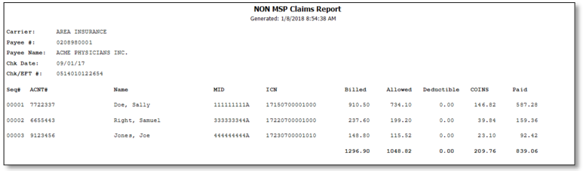

Making Sense of the Other Adjustments Report
This report shows those claims on the HIPAA 835v4010A1 or 835v5010A1 file that had some type of adjustment. Claims that have Late Filing and Interest and remittances that have Withholding and a Forwarding Balance appear on the report.
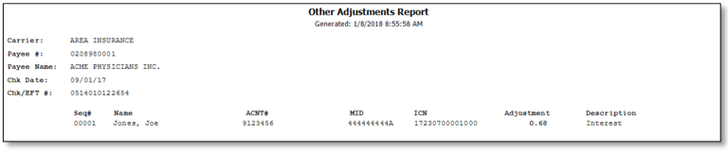

Making Sense of the Entire Remittance Report
This report contains the entire remittance report for the provider or supplier. You see the same information that was sent to the provider or supplier.
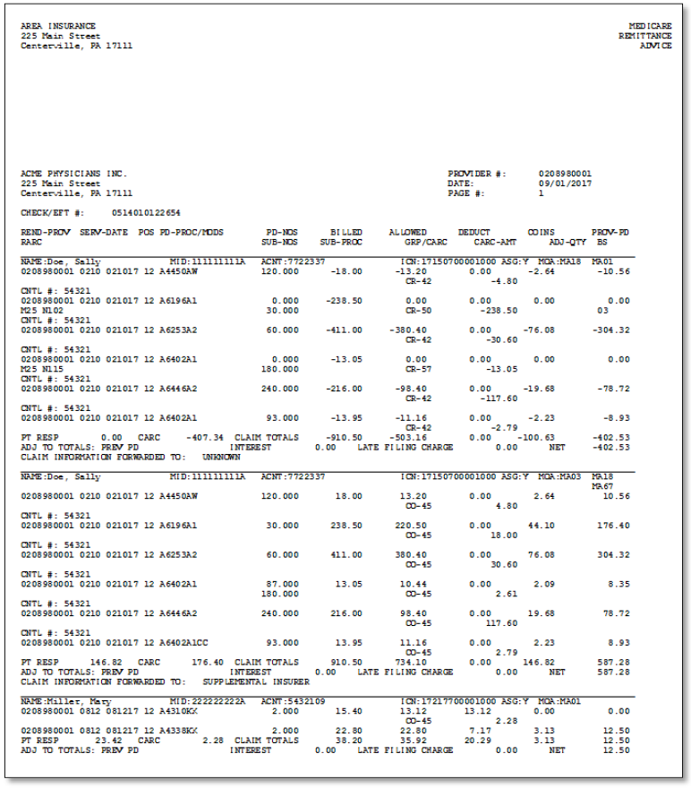

How to Print the Denied Service Lines Report
- Open Medicare Remit Easy Print by double-clicking the Medicare Remit Easy Print icon.
The Medicare Remit Easy Print Claim List tab opens.
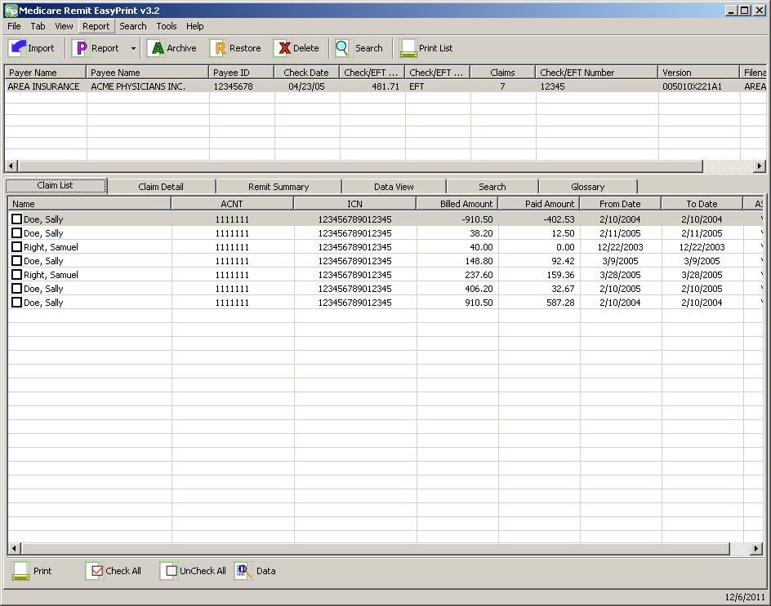
- Click the down arrow on Report.
The Report List appears.
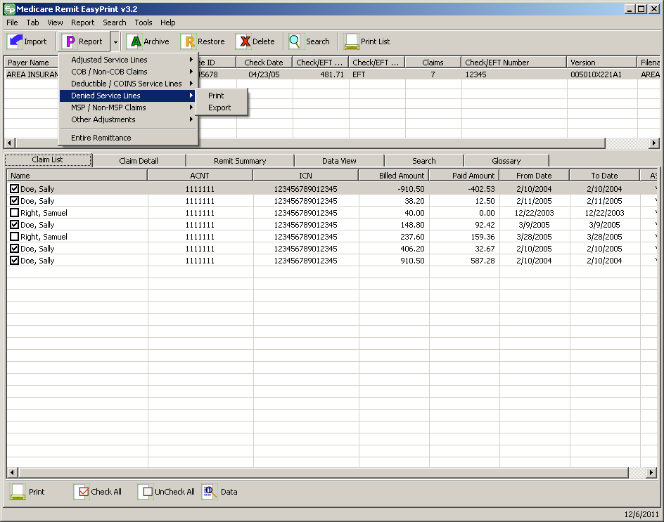
- Select Denied Service Lines.
- The Print and Export options appear:
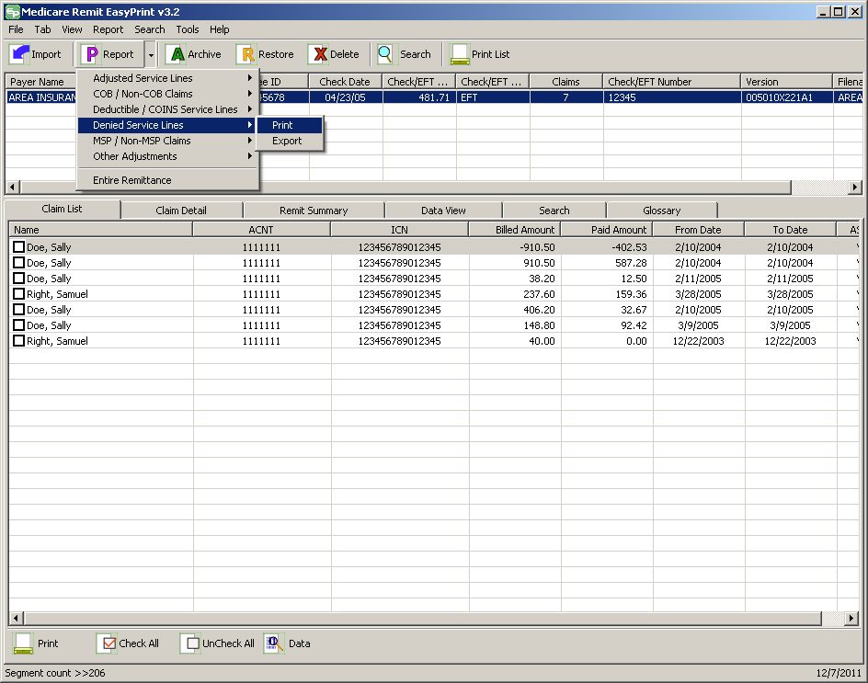
- Select Print.
The Print denied line report window opens.
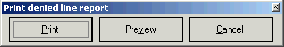
- Print the detail listing in one of the following ways:
- From the Print denied line report window, click Print to print the detail without previewing it.
The Print dialog opens, for example:
If you need to change the properties, click Properties and make changes as necessary.
Click OK. Medicare Remit Easy Print prints the detail at your default printer.
- From the Print denied line report window, click Preview to see a preview of the printed page before printing.
The Print Preview window opens
.
Click Printer at the top of the window.
Medicare Remit Easy Print prints the detail at your default printer.

How to Export the Denied Service Lines Report
You export the report in .csv (comma separated values) format.
- Open Medicare Remit Easy Print by double-clicking the Medicare Remit Easy Print icon.
The Medicare Remit Easy Print Claim List tab opens.
- Click the down arrow on Report.
The Report List appears.
- Select Denied Service Lines.
The Print and Export options appear.
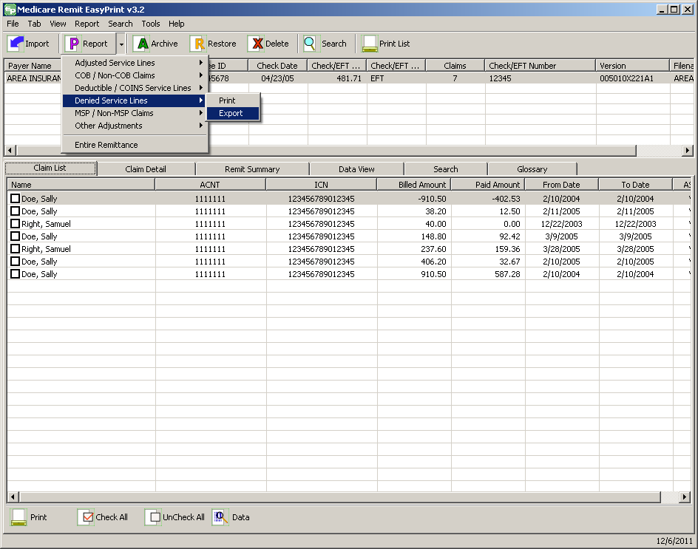
- Select Export.
The Export folder window opens.
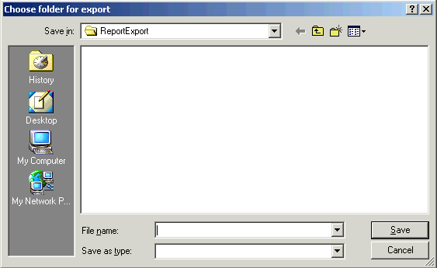
5. Enter the file name.
6. Click Save.

How to Print the Adjusted Service Lines Report
- Open Medicare Remit Easy Print by double-clicking the Medicare Remit Easy Print icon.
The Medicare Remit Easy Print Claim List tab opens.
- Click the down arrow on Report.
The Report List appears.
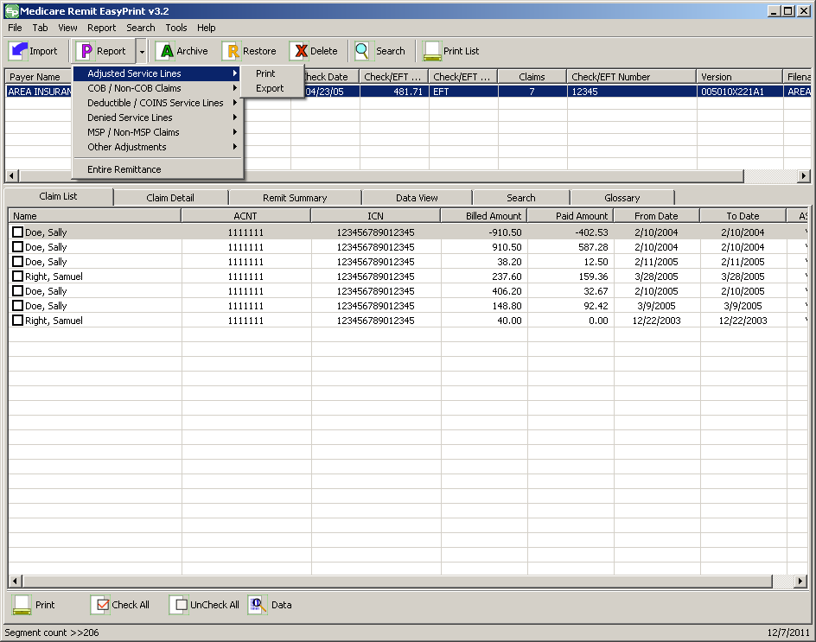
- Select Adjusted Service Lines.
The Print and Export options appear.
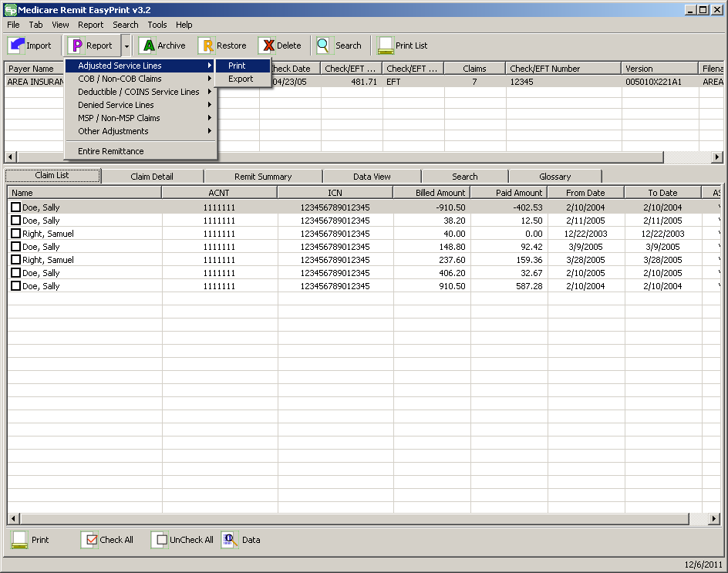
- Select Print. The Print remit listing window appears.
- From the Print remit listing window, print the detail listing in one of the following ways:
  - Click Print to print the detail without previewing it.
The Print dialog opens, for example:
If you need to change the properties, click Properties and make changes as necessary.
Click OK. Medicare Remit Easy Print prints the detail at your default printer.
  - Click Preview to view a preview of the printed page before printing.
The Print Preview window opens.
Click Printer at the top of the window.
Medicare Remit Easy Print prints the detail at your default printer.

How to Export the Adjusted Service Lines Report
- Open Medicare Remit Easy Print by double-clicking the Medicare Remit Easy Print icon.
The Medicare Remit Easy Print Claim List tab opens.
- Click the down arrow on Report.
The Report List appears.
- Select Adjusted Service Lines.

The Print and Export options appear.
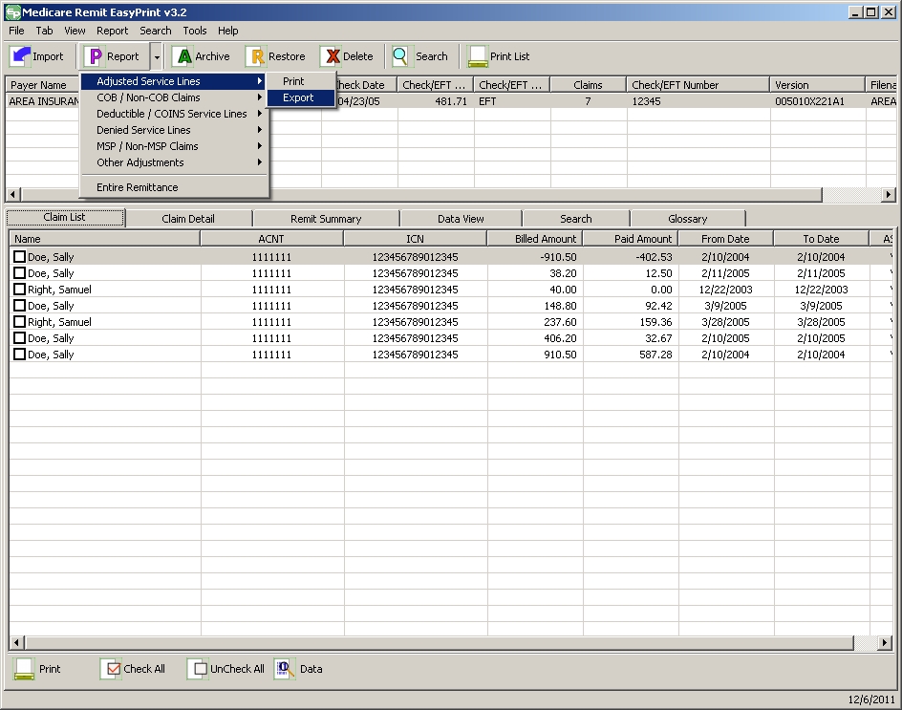
- Select Export.
The Export folder window opens.¹²
5. Enter the file name.
6. Click Save.

How to Print the Deductible Service Lines Report
- Open Medicare Remit Easy Print by double-clicking the Medicare Remit Easy Print icon.
The Medicare Remit Easy Print Claim List tab opens.
- Click the down arrow on Report.
The Report List appears.
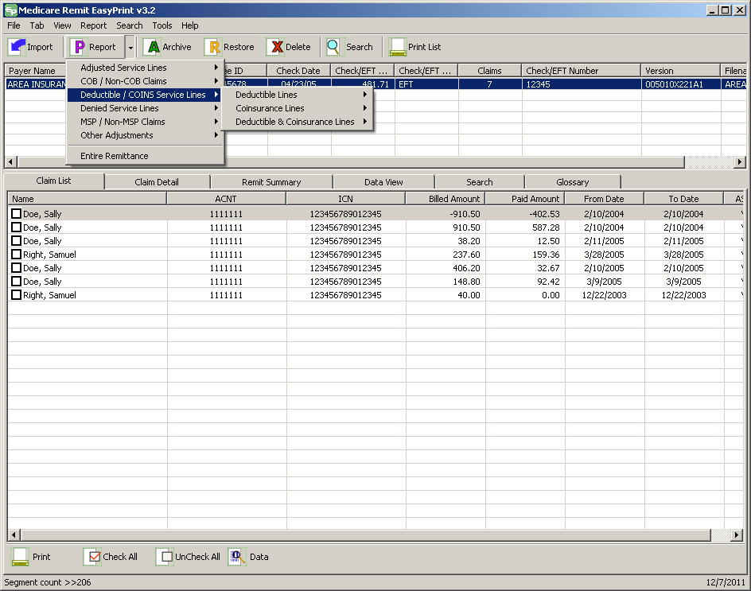
- Select Deductible/COINS Service Lines.
The Deductive/COINS Service Lines report options appear.
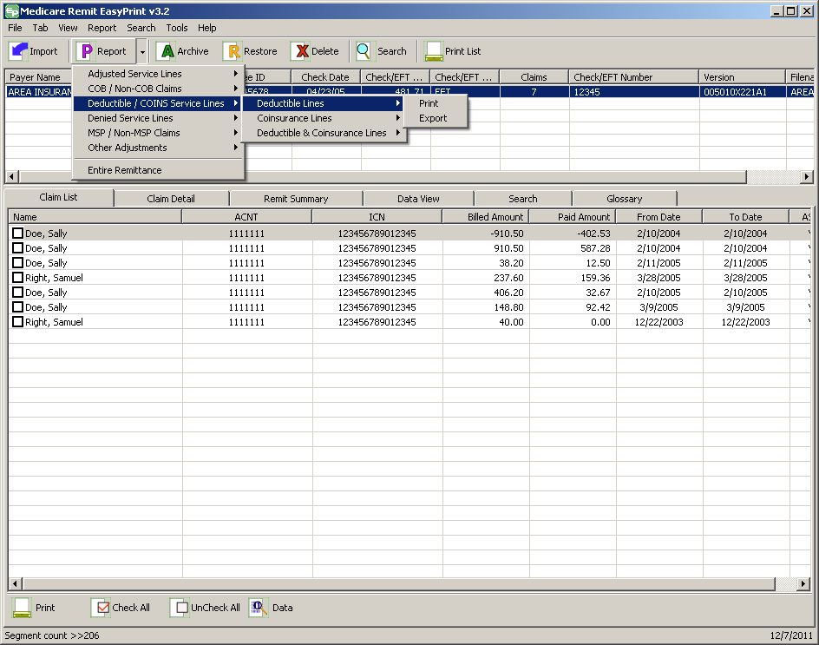
- Select Deductible Lines:
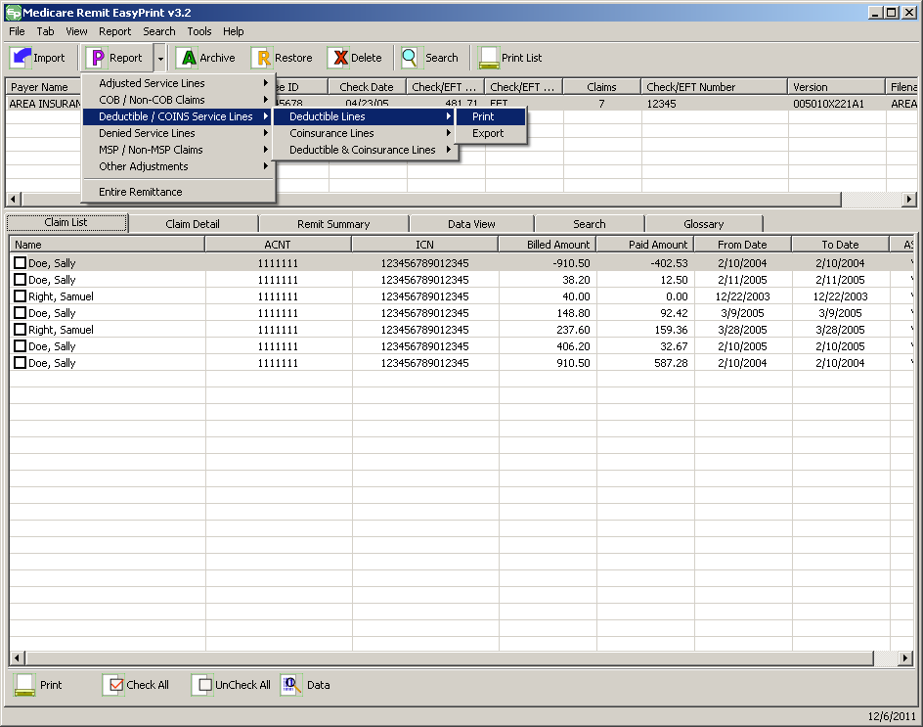
- Select Print. The Print remit listing window appears.
- Print the detail listing in one of the following ways:
- Click Print to print the detail without previewing it.
The Print dialog opens.
If you need to change the properties, click Properties and make changes as necessary.
Click OK. Medicare Remit Easy Print prints the detail at your default printer.
- Click Preview to view a preview of the printed page before printing.
The Print Preview window opens.
Click Printer at the top of the window.
Medicare Remit Easy Print prints the detail at your default printer.

How to Export the Deductible Service Lines Report
- Open Medicare Remit Easy Print by double-clicking the Medicare Remit Easy Print icon.
The Medicare Remit Easy Print Claim List tab opens.
- Click the down arrow on Report.
The Report List appears.
- Select Deductible/COINS Service Lines.
The Deductible/COIN Service Lines report options appear.
- Select Deductible Lines.
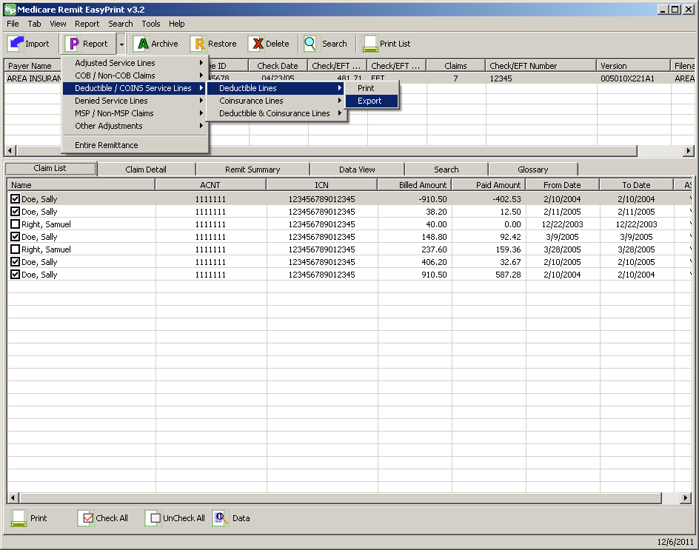
- Select Export.
- The Export folder window opens.¹²
- Enter the file name.
- Click Save.

How to Print the Coinsurance Service Lines Report
- Open Medicare Remit Easy Print by double-clicking the Medicare Remit Easy Print icon.
The Medicare Remit Easy Print Claim List tab opens.
- Click the down arrow on Report.
The Report List appears.
- Select Deductible/COINS Service Lines.
The Deductible/COINS Service Lines report options appear.
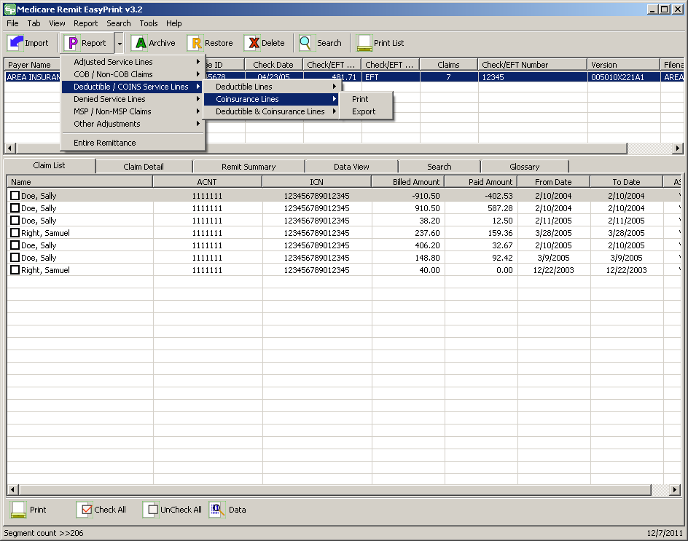
- Select Coinsurance Lines.
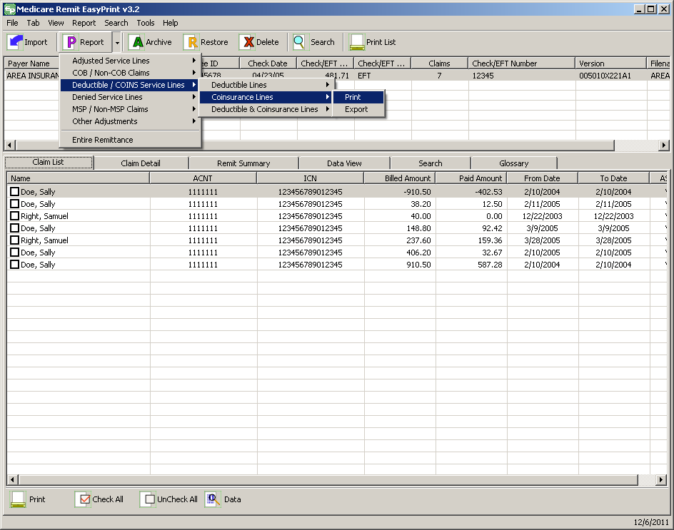
- Select Print. The Print remit listing window appears.
- Print the detail listing in one of the following ways:
  - From the Print remit listing window, click Print to print the detail without previewing it.
The Print dialog opens.
If you need to change the properties, click Properties and make changes as necessary.
Click OK. Medicare Remit Easy Print prints the detail at your default printer.
  - From the Print remit listing window, click Preview to view a preview of the printed page before printing.
The Print Preview window opens.
  - Click Printer at the top of the window.
Medicare Remit Easy Print prints the detail at your default printer.

How to Export the Coinsurance Service Lines Report
- Open Medicare Remit Easy Print by double-clicking the Medicare Remit Easy Print icon.
The Medicare Remit Easy Print Claim List tab opens.
- Click the down arrow on Report.
The Report List appears.
- Select Deductible/COINS Service Lines.
The Deductible/COIN report options appear.
- Select Coinsurance Lines.
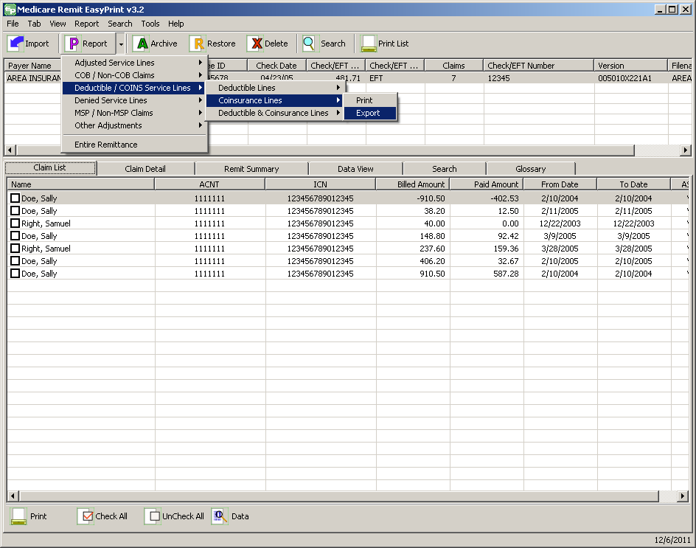
- Select Export.
The Export folder window opens.¹²
6. Enter the file name.
7. Click Save.

How to Print the Deductible/Coinsurance Service Lines Report
- Open Medicare Remit Easy Print by double-clicking the Medicare Remit Easy Print icon.
The Medicare Remit Easy Print Claim List tab opens.
- Click the down arrow on Report.
The Report List appears.
- Select Deductible/COINS Service Lines.
The Deductible/COIN report options appear.
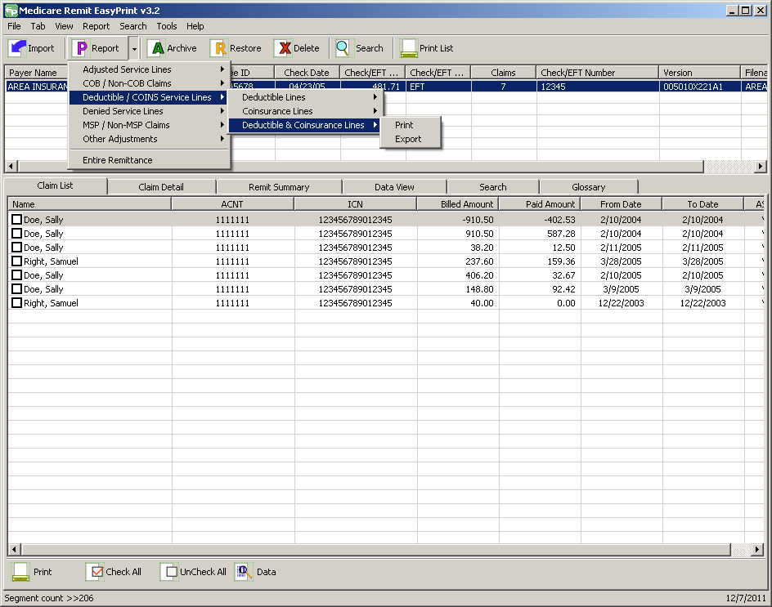
- Select Deductible & Coinsurance Lines:
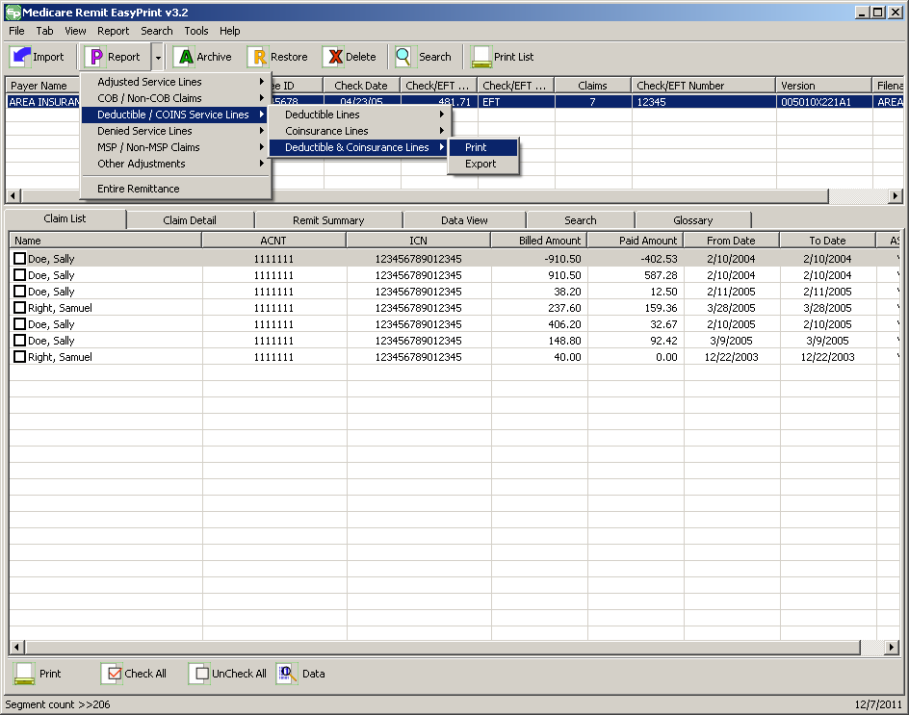
- Select Print.
The Print remit listing window appears.
- Print the detail listing in one of the following ways:
- From the Print remit listing window, click Print to print the detail without previewing it.
The Print dialog box opens.
If you need to change the properties, click Properties and make changes as necessary.
Click OK. Medicare Remit Easy Print prints the detail at your default printer.
- From the Print remit listing window, click Preview to view a preview of the printed page before printing.
Click Printer at the top of the window.
Medicare Remit Easy Print prints the detail at your default printer.

How to Export the Deductible/Coinsurance Service Lines Report
- Open Medicare Remit Easy Print by double-clicking the Medicare Remit Easy Print icon.
The Medicare Remit Easy Print Claim List tab opens.
- Click the down arrow on Report.
The Report List appears.
- Select Deductible/COINS Service Lines.
The Deductible/COINS report options appear.
- Select the Deductible & Coinsurance Lines:
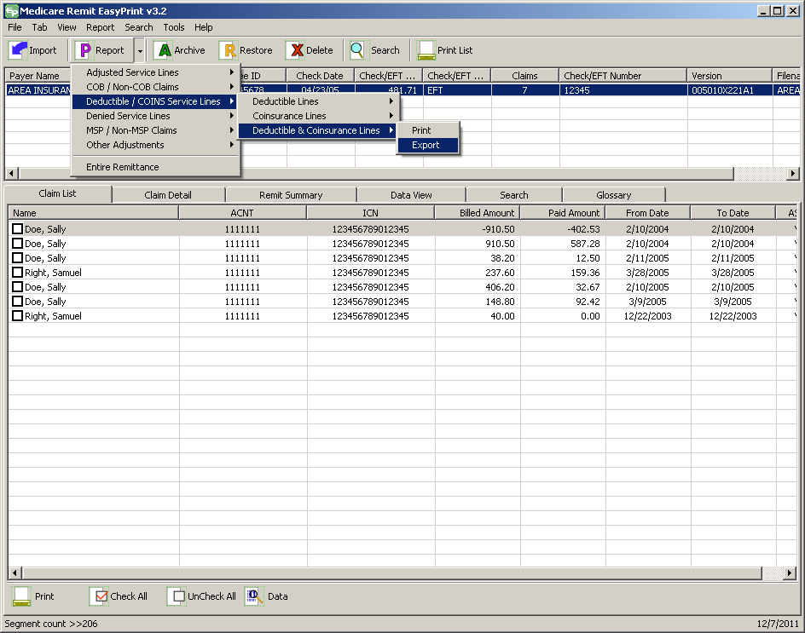
- Select Export.
The Export folder window opens.¹²
6. Enter the file name.
7. Click Save.

How to Print the COB Claims Report
- Open Medicare Remit Easy Print by double-clicking the Medicare Remit Easy Print icon.
The Medicare Remit Easy Print Claim List tab opens.
- Click the down arrow on Report.
The Report List appears.
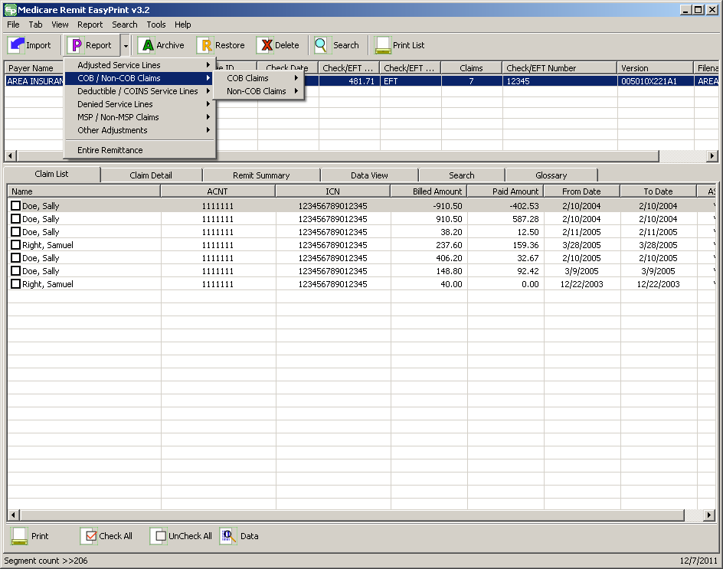
- Select COB/Non-COB Claims.

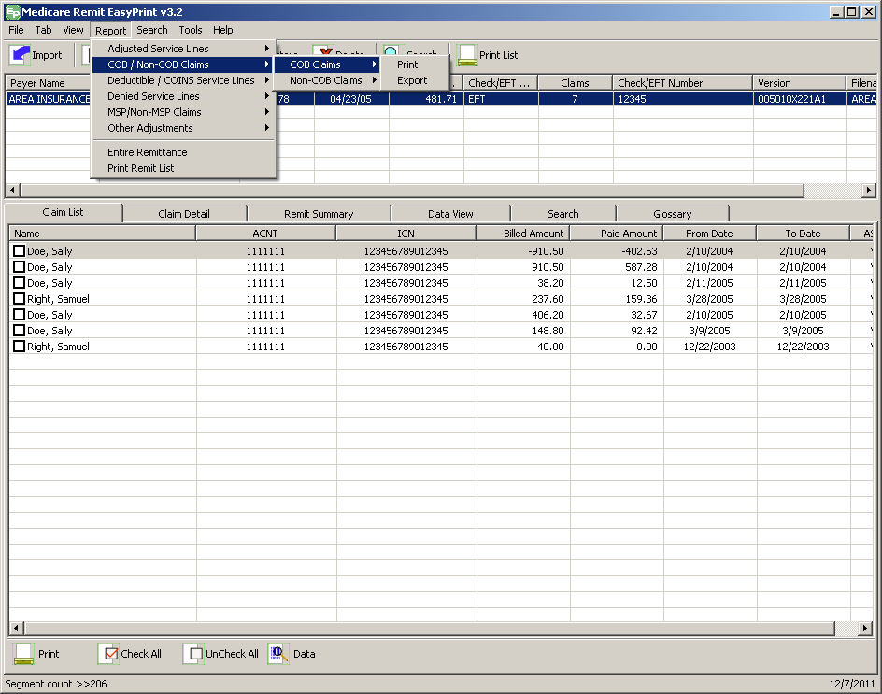
- Select COB Claims.
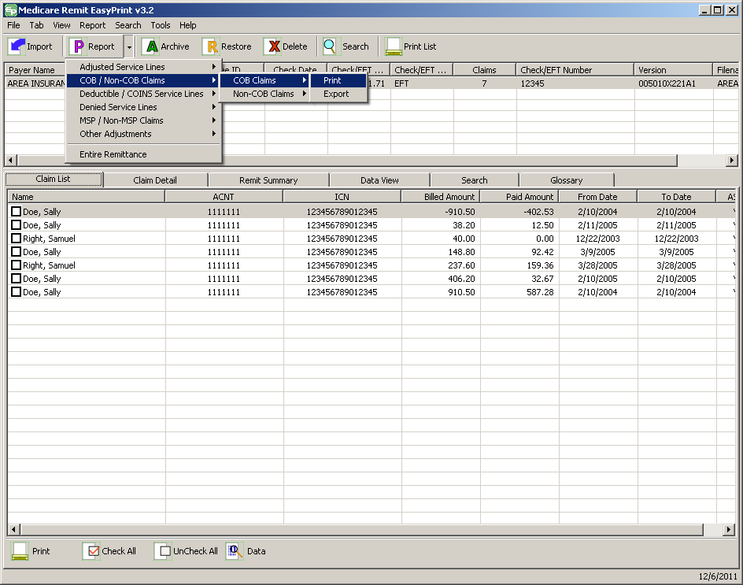
The Print and Export options appear.
- Select Print.
The Print denied line report window opens.
- Print the detail listing in one of the following ways:
- From the Print denied line report window, click Print to print the detail without previewing it.
The Print dialog box opens.
If you need to change the properties, click Properties and make changes as necessary.
Click OK. Medicare Remit Easy Print prints the detail at your default printer.
- From the Print denied line report window, click Preview to view a preview of the printed page before printing.
The Print Preview window opens.
Click Printer at the top of the window.
Medicare Remit Easy Print prints the detail at your default printer.

How to Export the COB Claims Report
You export the report in .csv (comma separated values) format.
- Open Medicare Remit Easy Print by double-clicking the Medicare Remit Easy Print icon.
The Medicare Remit Easy Print Claim List tab opens.
- Click the down arrow on Report.
The Report List appears.
- Select COB/Non-COB Claims.
- Select COB Claims.
The Print and Export options appear.
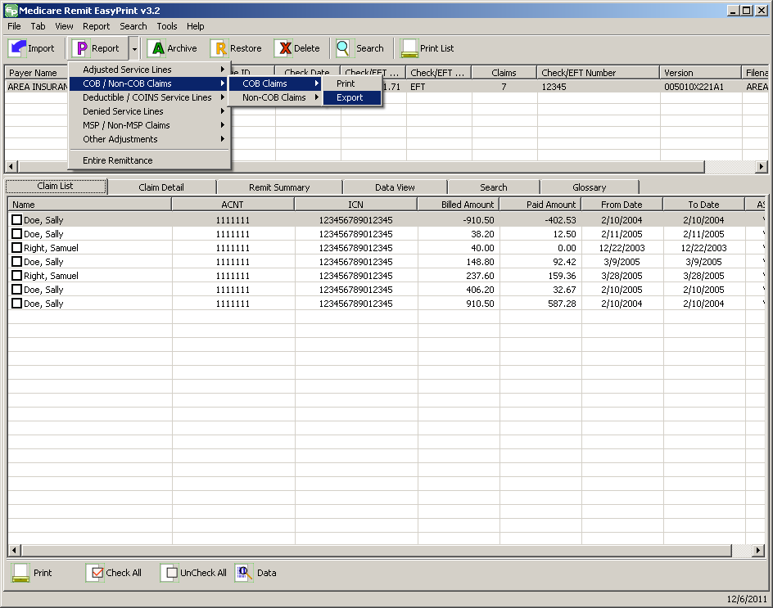
- Select Export.
The Export folder window opens.
- Enter the file name.
- Click Save.

How to Print the Non-COB Claims Report
- Open Medicare Remit Easy Print by double-clicking the Medicare Remit Easy Print icon.
The Medicare Remit Easy Print Claim List tab opens.
- Click the down arrow on Report.
The Report List appears.
- Select COB/Non-COB Claims.

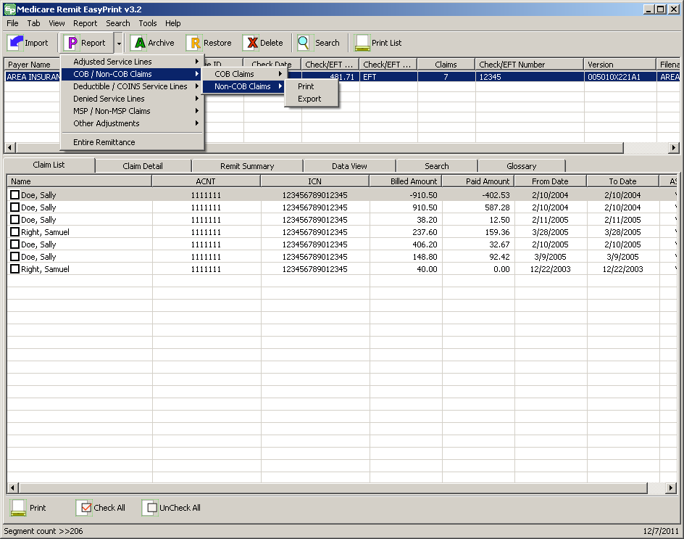
- Select Non-COB Claims.
The Print and Export options appear.
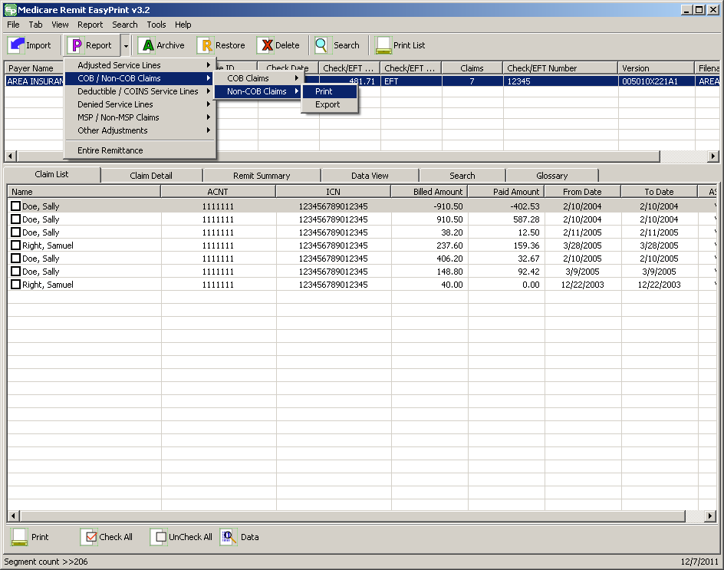
- Select Print.
The Print denied line report window opens.
- Print the detail listing in one of the following ways:
- From the Print denied line report window, click Print to print the detail without previewing it.
The Print dialog opens, for example:
If you need to change the properties, click Properties and make changes as necessary.
Click OK. Medicare Remit Easy Print prints the detail at your default printer.
- From the Print denied line report window, click Preview to view a preview of the printed page before printing.
The Print Preview window opens.
Click Printer at the top of the window.
Medicare Remit Easy Print prints the detail at your default printer.

How to Export the Non-COB Claims Report
You export the report in .csv (comma separated values) format.
- Open Medicare Remit Easy Print by double-clicking the Medicare Remit Easy Print icon.
The Medicare Remit Easy Print Claim List tab opens.
- Click the down arrow on Report.
The Report List appears.
- Select COB/Non-COB Claims.
- Select Non-COB Claims.
The Print and Export options appear.
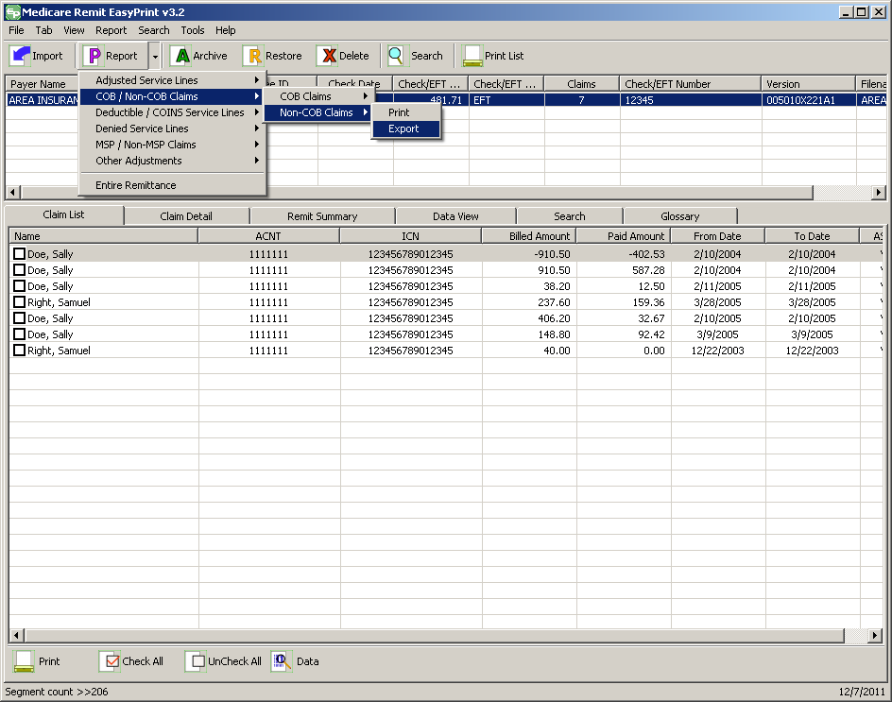
- Select Export.
The Export folder window opens.¹³
- Enter the file name.
- Click Save.

How to Print the MSP Claims Report
- Open Medicare Remit Easy Print by double-clicking the Medicare Remit Easy Print icon.
The Medicare Remit Easy Print Claim List tab opens.
- Click the down arrow on Report.
The Report List appears.
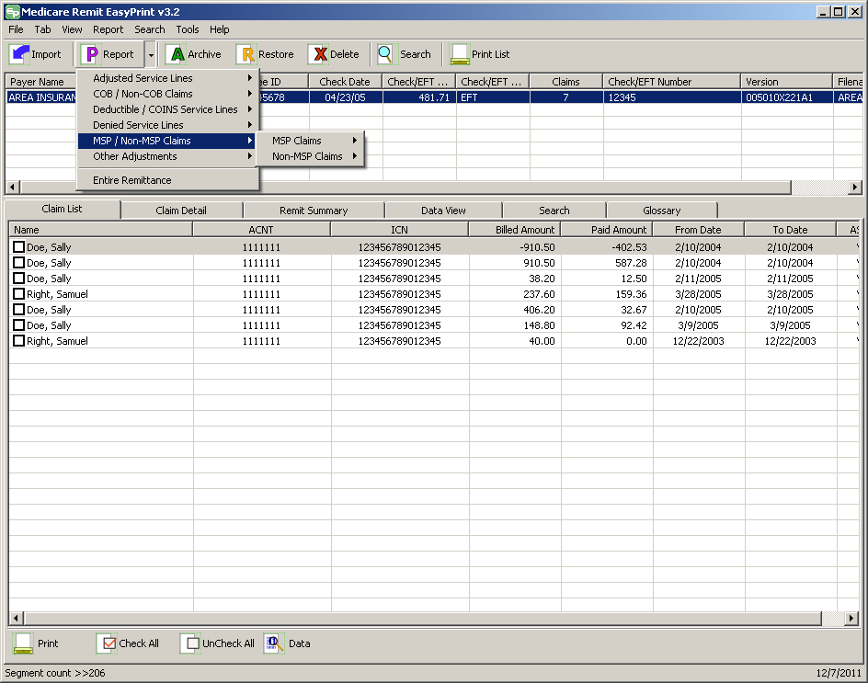
- Select MSP/Non-MSP Claims.
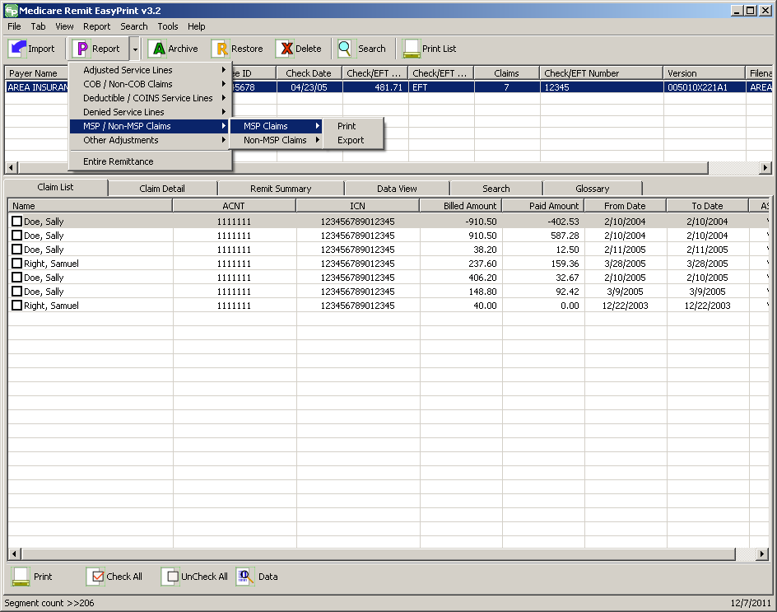
- Select MSP Claims.
The Print and Export options appear.
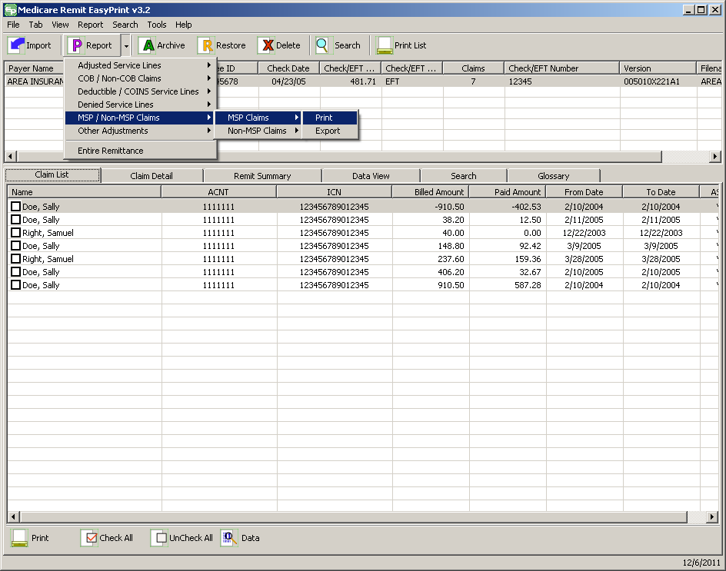
- Select Print.
The Print denied line report window opens.
- Print the detail listing in one of the following ways:
  - From the Print denied line report window, click Print to print the detail without previewing it.
The Print dialog box opens.
If you need to change the properties, click Properties and make changes as necessary.
Click OK. Medicare Remit Easy Print prints the detail at your default printer.
  - From the Print denied line report window, click Preview to view a preview of the printed page before printing.
The Print Preview window opens.
Click Printer at the top of the window.
Medicare Remit Easy Print prints the detail at your default printer.

How to Export the MSP Claims Report
You export the report in .csv (comma separated values) format.
- Open Medicare Remit Easy Print by double-clicking the Medicare Remit Easy Print icon.
The Medicare Remit Easy Print Claim List tab opens.
- Click the down arrow on Report.
The Report List appears.
- Select MSP/Non-MSP Claims.
- Select MSP Claims.
The Print and Export options appear.
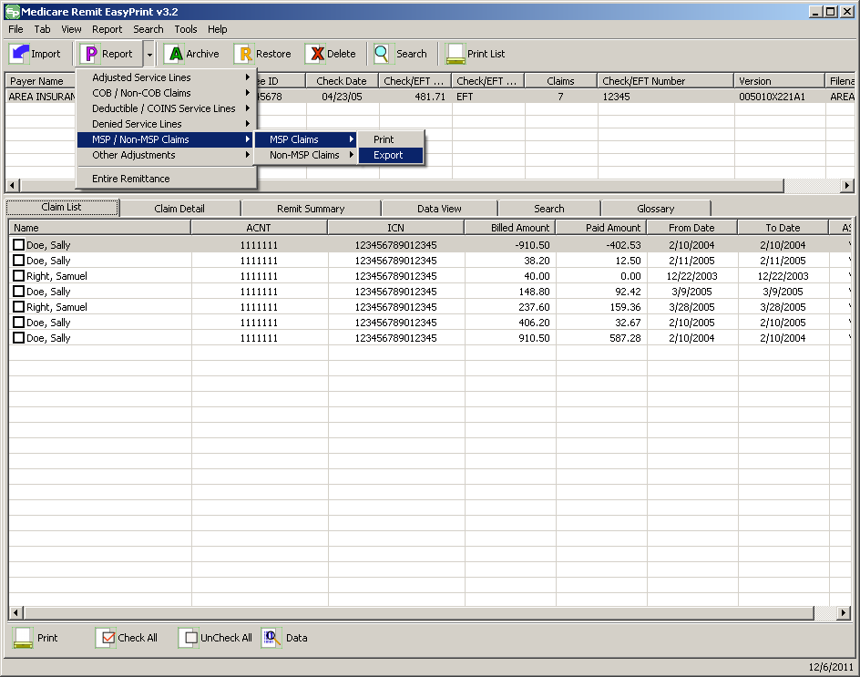
- Select Export.
The Export folder window opens.¹³
- Enter the file name.
- Click Save.

How to Print the Non-MSP Claims Report
- Open Medicare Remit Easy Print by double-clicking the Medicare Remit Easy Print icon.
The Medicare Remit Easy Print Claim List tab opens.
- Click the down arrow on Report.
The Report List appears.
- Select MSP/Non-MSP Claims.
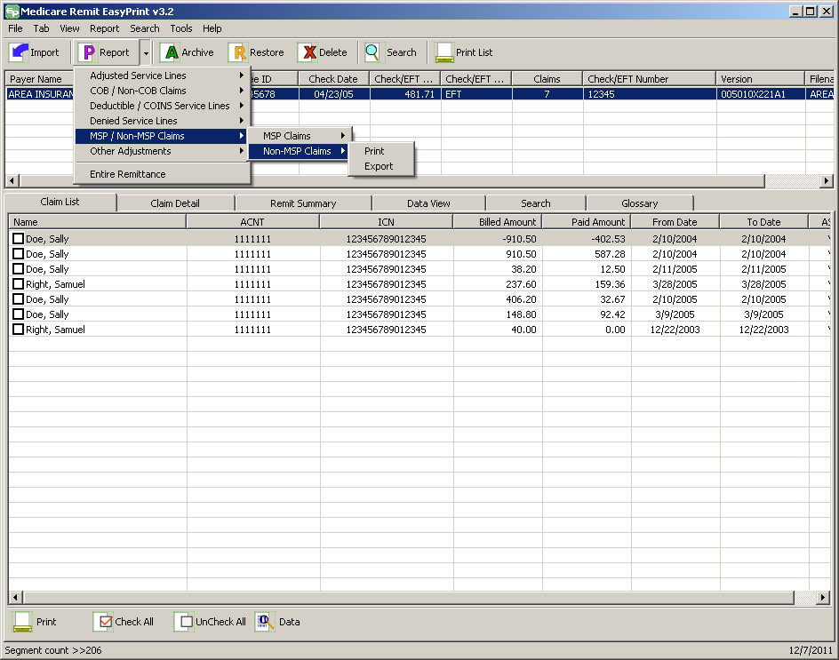
- Select Non-MSP Claims.
The Print and Export options appear.
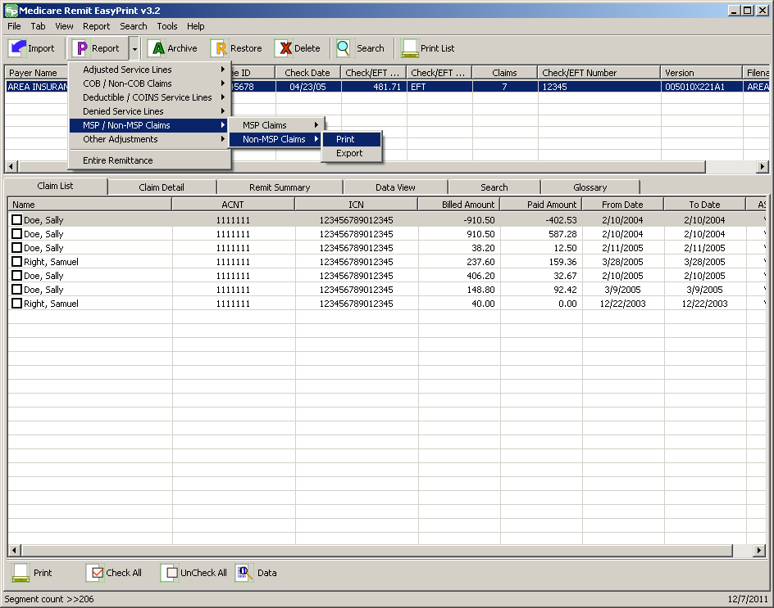
- Select Print.
The Print denied line report window opens.
- Print the detail listing in one of the following ways:
  - From the Print denied line report window, click Print to print the detail without previewing it.
The Print dialog box opens.
If you need to change the properties, click Properties and make changes as necessary.
Click OK. Medicare Remit Easy Print prints the detail at your default printer.
  - From the Print remit listing window, click Preview to view a preview of the printed page before printing.
The Print Preview window opens.
Click Printer at the top of the window.
Medicare Remit Easy Print prints the detail at your default printer.

How to Export the Non-MSP Claims Report
You export the report in .csv (comma separated values) format.
- Open Medicare Remit Easy Print by double-clicking the Medicare Remit Easy Print icon.
The Medicare Remit Easy Print Claim List tab opens.
- Click the down arrow on Report.
The Report List appears.
- Select MSP/Non-MSP Claims.
- Select Non-MSP Claims.
The Print and Export options appear.
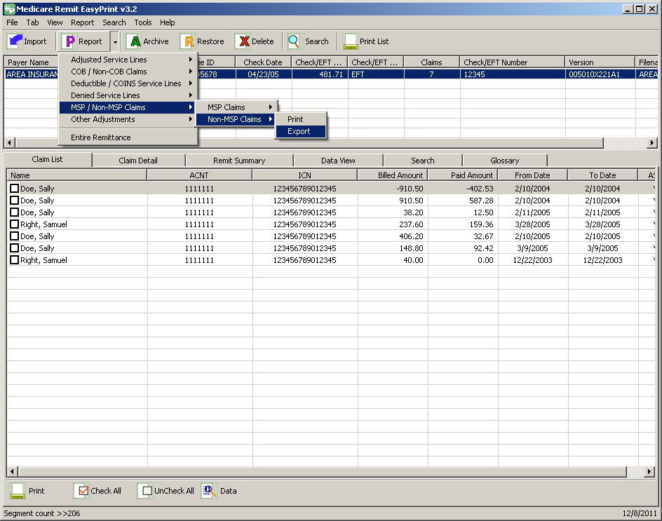
- Select Export.
The Export folder window opens.¹³
- Enter the file name.
- Click Save.

How to Print the Other Adjustments Report
- Open Medicare Remit Easy Print by double-clicking the Medicare Remit Easy Print icon.
The Medicare Remit Easy Print Claim List tab opens.
- Click the down arrow on Report.
The Report List appears.
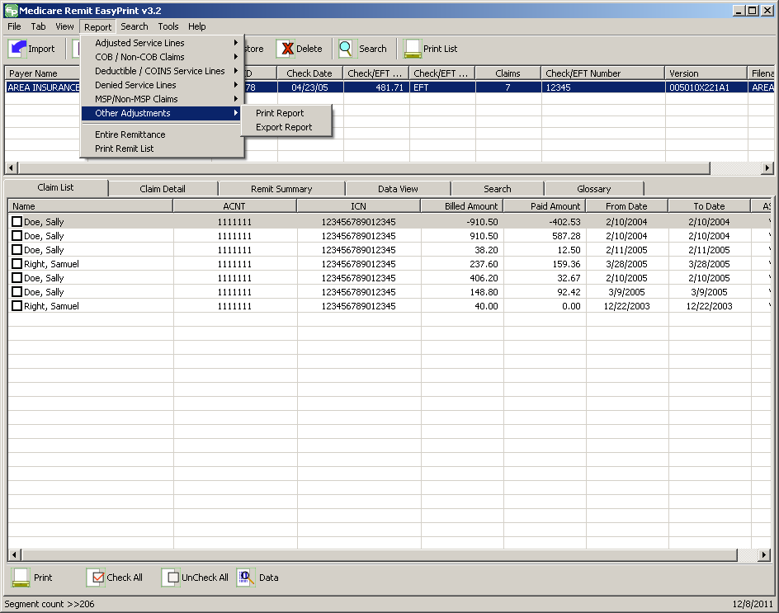
- Select Other Adjustments.
The Print and Export options appear.
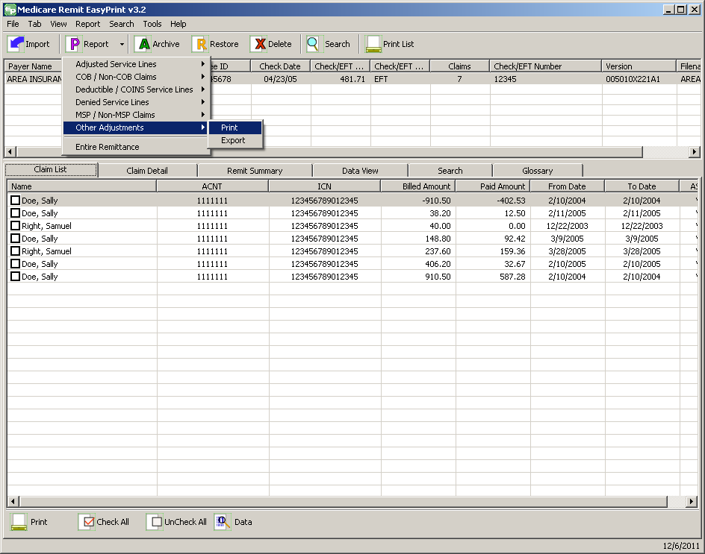
- Select Print.
The Print denied line report window opens.
- Print the detail listing in one of the following ways:
  - From the Print denied line report window, click Print to print the detail without previewing it.
The Print dialog opens.
If you need to change the properties, click Properties and make changes as necessary.
Click OK. Medicare Remit Easy Print prints the detail at your default printer.
  - From the Print denied line report window, click Preview to view a preview of the printed page before printing.
The Print Preview window opens.
Click Printer at the top of the window.
Medicare Remit Easy Print prints the detail at your default printer.

How to Export the Other Adjustments Report
You export the report in .csv (comma separated values) format.
- Open Medicare Remit Easy Print by double-clicking the Medicare Remit Easy Print icon.
The Medicare Remit Easy Print Claim List tab opens.
- Click the down arrow on Report.
The Report List appears.
- Select Other Adjustments.
The Print and Export options appear.
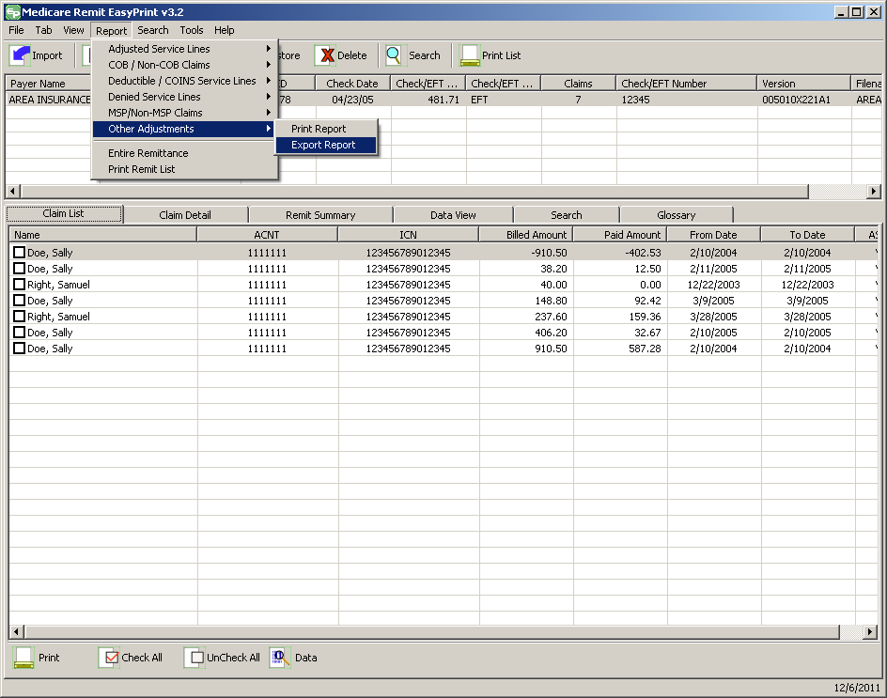
- Select Export Report.
The Export folder window opens.¹³
- Enter the file name.
- Click Save.

How to Print the Entire Remittance Report
- Open Medicare Remit Easy Print by double-clicking the Medicare Remit Easy Print icon.
The Medicare Remit Easy Print Claim List tab opens.
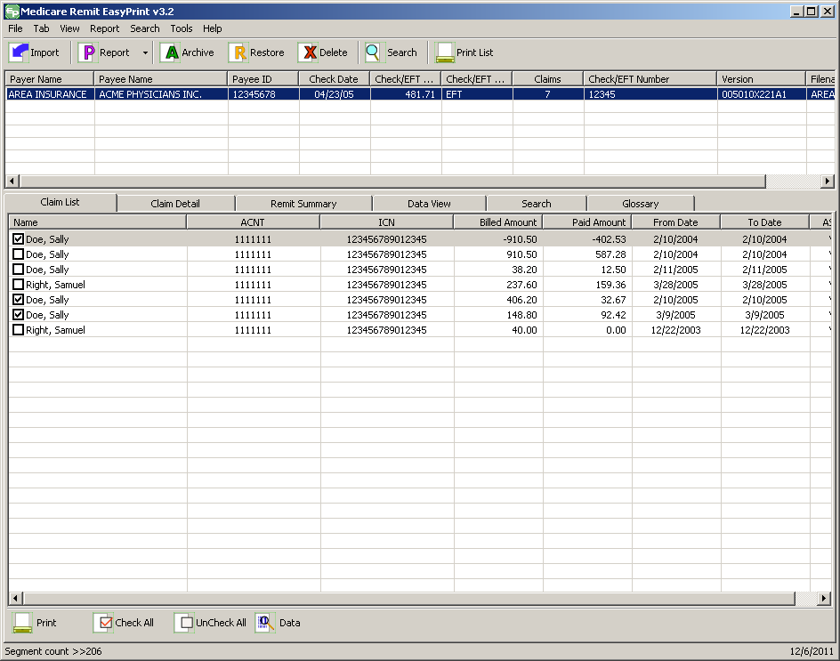
- Click the down arrow on Report.
The Report List appears.
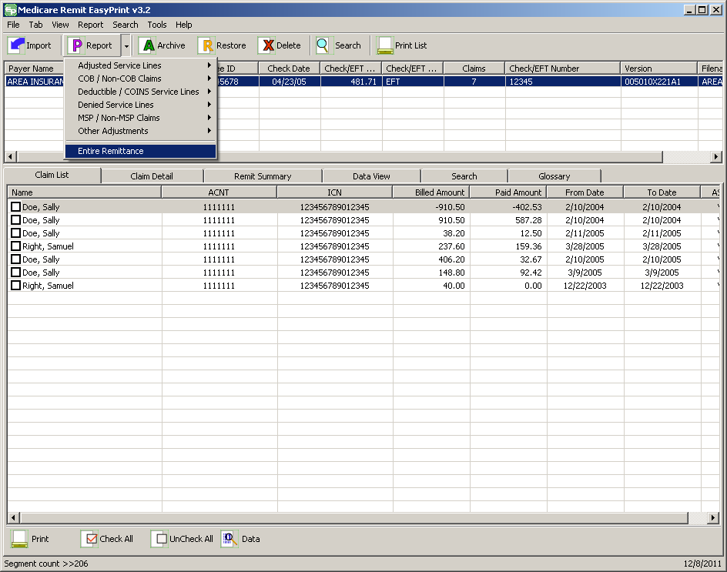
- Select Entire Remittance.
The Print remit listing window appears.
- Print the detail listing in one of the following ways:
  - From the Print remit listing window, click Print to print the detail without previewing it.
The Print dialog box opens.
If you need to change the properties, click Properties and make changes as necessary.
Click OK. Medicare Remit Easy Print prints the detail at your default printer.
  - From the Print Remit listing window, click Preview to view a preview of the printed page before printing.
The Print Preview window opens.
Click Printer at the top of the window.
Medicare Remit Easy Print prints the detail at your default printer.

Housekeeping for the Import Files
Housekeeping includes:
- Archiving files
- Restoring files
- Deleting files

Archiving Import Files
Medicare Remit Easy Print does NOT automatically archive any Import file, and Import files can slow down the processing time of the PC.
Therefore, Medicare Remit Easy Print lets you archive Import files. The location you choose for the archive must have adequate security to protect PHI.

How to Archive Import files
- Open Medicare Remit Easy Print by double-clicking the Medicare Remit Easy Print icon.
The Medicare Remit Easy Print Claim List tab opens.
- On the top of the window, select the file that you want to archive and click Archive.
The Archive Imported Files window opens.
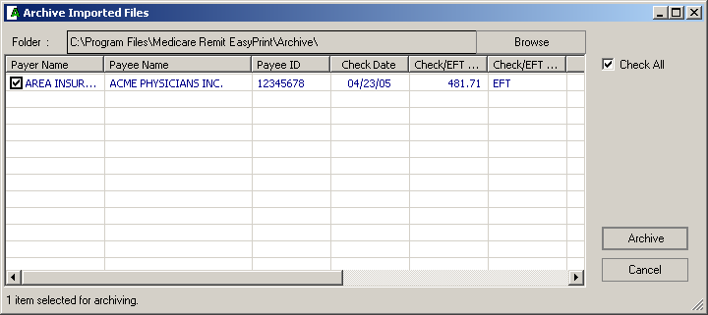
- Select the file(s) you want to archive by checking the box or boxes.
This activates Archive.
- Click Archive.
Medicare Remit Easy Print moves the file to the Archive folder.

Restoring Import files
You can restore an Import file after you have archived it.
For information about archiving Import files, see Archiving Import Files.

How to Restore Import files
- Open Medicare Remit Easy Print by double-clicking the Medicare Remit Easy Print icon .
The Medicare Remit Easy Print Claim List tab opens.
- On the top of the window, click Restore.
The Restore Imported Files window opens.
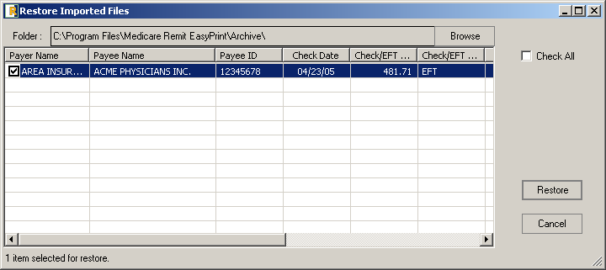
- Select the file(s) you want to restore by checking the box or boxes. ¹⁵
This activates Restore.
- Click Restore.
Medicare Remit Easy Print moves the file from the Archive folder to the Import folder.
The file is now available for viewing on your C drive at C:\Program Files\Medicare Remit EasyPrint\Import.
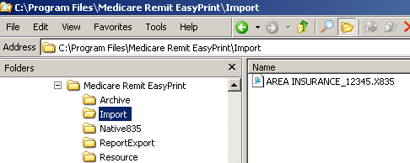

Deleting Import files
If you delete an Import file by mistake, you must re-import the HIPAA 835 file. You cannot restore the Import file.

How to Delete an Import file
- Open Medicare Remit Easy Print by double-clicking the Medicare Remit Easy Print icon.
The Medicare Remit Easy Print Claim List tab opens.
- On the top of the window, click Delete.
The Delete selected import file(s) window opens.
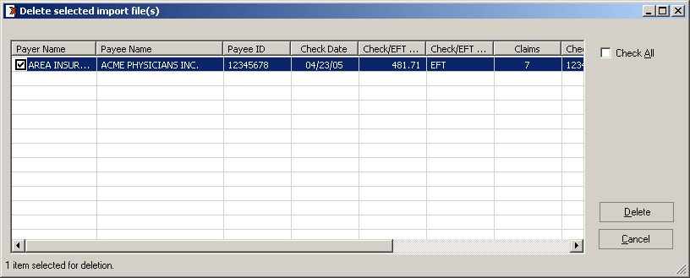
- Select the file(s) you want to delete by checking the box(es).
This activates Delete.
- Click Delete.
Medicare Remit Easy Print deletes the file(s).

Using Keystroke Shortcuts
You can use a series of keystrokes to complete a number of tasks.
To Do This… | Use This Combination…
Import a HIPAA 835 file | Alt + F + I
View a list of claims | Alt + V + L
View claim detail | Alt + V + D
View totals | Alt + V + S
View the way the data is stored in the file | Alt + V + V
Search the Remittance Advice | Alt + V + E or  Alt + S + S
View the CARC and RARC codes for the Remittance Advice | Alt + V + G
Look up the meaning of a CARC/RARC code | Alt + T + C
Print the Adjusted Service Lines Report | Alt + R + A + P
Export the Adjusted Service Lines Report | Alt + R + A + E
Print the COB Claims Report | Alt + R + B + C + P
Export the COB Claims Report | Alt + R + B + C + E
Print the Non-COB Claims Report | Alt + R + B + N + P
Export the Non-COB Claims Report | Alt + R + B + N + E
Print the Deductible Service Lines Report | Alt + R + E + D + P
Export the Deductible Service Lines Report | Alt + R + E + D + E
Print the Coinsurance Service Lines Report | Alt + R + E + C + P
Export the Coinsurance Service Lines Report | Alt + R + E + C + E
Print the Deductible/Coinsurance Service Lines Report | Alt + R + E + E + P
Export the Deductible/Coinsurance Service Lines Report | Alt + R + E + E + E
Print the Denied Service Lines Report | Alt + R + D + P
Export the Denied Service Lines Report | Alt + R + D + E
Print the MSP Claims Report | Alt + R + M + M + P
Export the MSP Claims Report | Alt + R + M + M + E
Print the Non-MSP Claims Report | Alt + R + M + N + P
Export the Non-MSP Claims Report | Alt + R + M + N + E
Print the Other Adjustments Report | Alt + R + O + P
Export the Other Adjustments Report | Alt + R + O + E
Print the Entire Remittance Report | Alt + R + R
Print the Remit List | Alt + R + P
Archive Import files | Alt + T + A
Restore archived Import files | Alt + T + R
Delete Import files | Alt + T + D
With the Claim List Tab Selected: | No data
Print Claim List | Alt + B + P
Check all claims in the list | Alt + B + C
Uncheck all claims in the list | Alt + B + U
With the Claim Detail Tab Selected: | No data
Print Claim Detail | Alt + B + P
Zoom In | Alt + B + I
Zoom Out | Alt + B + O
Reset Zoom | Alt + B + R
Show Glossary ( check box ) | Alt + B + S
With the Remit Summary Tab Selected: | No data
Print Summary | Alt + B + P
Zoom In | Alt + B + I
Zoom Out | Alt + B + O
Reset Zoom | Alt + B + R
With the Search Tab Selected: | No data
Print Results | Alt + B + P
Claim Detail Results | Alt + B + C
With the Glossary Tab Selected: | No data
Zoom In | Alt + B + I
Zoom Out | Alt + B + O
Reset Zoom | Alt + B + R
Codes | Alt + B + C

Appendix A: MREP RA/HIPAA 835v5010A1 Segment Field Crosswalk
This information can help you if you need to troubleshoot the Import file.
Note: This appendix represents the fields of an 835v5010A1 electronic remittance advice. However, MREP can also print or display remittances in the 4010A1format. Fields marked with an asterisk (*) below are not found on the 4010A1 format and do not appear when printed or shown.
Remittance Advice Field | 835 Loop ID | 835 Segment Field | Identification/Comments
Payer (Contractor) Name | 1000A | N102 | N101 = ‘PR’
Payer (Contractor) Address | 1000A | N301 | N101 = ‘PR’, ADDR1
 |  | N302 | N101 = ‘PR’, ADDR2
Payer (Contractor) City | 1000A | N401 | N101 = ‘PR’
Payer (Contractor) State | 1000A | N402 | N101 = ‘PR’
Payer (Contractor) ZIP | 1000A | N403 | N101 = ‘PR’
* PAYER’S WEB SITE: | 1000A | PER04 | PER01 = ‘IC’
* PAYER BUSINESS CONTACT INFORMATION: | 1000A |  | PER01= ‘CX’
* Name |  | PER02
* Email Address (up to 50 positions) |  | PER04 or PER06 | PER03 or PER05 = ‘EM’ (respectively)
* Telephone Number |  | PER04 and PER06  PER06 and PER08 | PER03 = ‘TE’ and PER05 = ‘EX’  PER05 = ‘TE’ and PER07 = ‘EX’
* PAYER TECHNICAL CONTACT INFORMATION: | 1000A |  | PER01= ‘BL’
Payee (Provider) Name | 1000B | N102 | N101 = ‘PE’
Payee (Provider) Address | 1000B | N301  N302 | N101 = ‘PE’, ADDR1  N101 = ‘PE’, ADDR2
Payee (Provider) City | 1000B | N401 | N101 = ‘PE’
Payee (Provider) State | 1000B | N402 | N101 = ‘PE’
Payee (Provider) ZIP | 1000B | N403 | N101 = ‘PE’
PROVIDER #  or  NPI # | 1000B | N104  or  REF02 | N101 = ‘PE’ & N103 = ‘XX’  Payee level REF01 = ‘1C’
Date |  | BPR16
CHECK/EFT # |  | TRN02 | BPR04 = ‘CHK’ or ‘EFT’ or ‘NON’
Assigned claims |  |  | LX01 = ‘1’, pertains only to Medicare
NAME  (Patient Last Name) | 2100 | NM103 | NM101 = ‘QC’
NAME  (Patient First Name) | 2100 | NM104 | NM101 = ‘QC’ / NM102 = ‘1’
NAME  (Patient Middle Name) | 2100 | NM105 | NM101 = ‘QC’ / NM102 = ‘1’
MID  (Patient ID) | 2100 | NM109 | NM108 = ‘HN’ or ‘C’
ACNT  (Patient Account Number) | 2100 | CLP01
ICN  (Claim Control Number) |  | CLP07
ASG  (Claim Assignment) | 2000 |  | Hard-coded ‘Y’ for Medicare when LX01 = ‘1’
MOA  (Claim Level Remark Codes) | 2100 | MOA03, MOA04, MOA05, MOA06, MOA07
REND PROV  (Rendering Provider) | 2110 | REF02 | REF01 = HPI or  REF01 = ‘1C’
 | 2100 | NM109 or  REF02 | NM108 = ‘XX’ or  REF01 = ‘1C’
 | 1000B | N104 or  REF02 or  spaces | N103 = ‘XX’ or  REF01 = ‘XX’
SERV-DATE  (From Service Date) | 2110 | DTM02 | Line level DTM01 = ‘150’ or ‘472’ else Claim level DTM01 = ‘232’
SERV-DATE  (To Service Date) | 2110 | DTM02 | Line level DTM01 = ‘151’ or ‘472’ else Claim level DTM01 = ‘233’
POS  (Place of Service) | 2110 | REF02 | REF01 = ‘LU’
PD-NOS  (Paid Number of Services) | 2110 | SVC05
PD-PROC  (Procedure code – paid and if down-coded then the original procedure appears under SUB-PROC.) | 2110 | SVC01-2 | SVC01-1 = ‘HC’ or ‘N4’
MODS  (Procedure Code Modifiers) | 2110 | SVC01-3, SVC01-4, SVC01-5, SVC01-6 | SVC01-1 = ‘HC’ or ‘N4’
BILLED  (Billed Amount) | 2110 | SVC02
ALLOWED  (Allowed Amount) | 2110 | AMT02 | AMT01 = ‘B6’
DEDUCT  (Deductible Amount) | 2110 | CAS03 or CAS06 or CAS09 or CAS12 or CAS15 or CAS18 | CAS01 = ‘PR’ & (CAS02 = ‘1’ or CAS05 = ‘1’ or CAS08 = ‘1’ or CAS11 = ‘1’ or CAS14 = ‘1’ or CAS17 = ‘1’)
COINS  (Coinsurance Amount) | 2110 | CAS03 or CAS06 or CAS09 or CAS12 or CAS15 or CAS18 | CAS01 = ‘PR’ & (CAS02 = ‘2’ or CAS05 = ‘2’ or CAS08 = ‘2’ or CAS11 = ‘2’ or CAS14 = ‘2’ or CAS17 = ‘2’)
GRP/CARC  (Group/Claim Adjustment Reason Code) | 2110 | CAS01-CAS02, CAS05, CAS08, CAS11, CAS14, CAS17 | Do not print CAS01 = ‘PR’ and ((CAS02 = ‘1’ or ‘2’) or (CAS05 = ‘1’ or ‘2’) or (CAS08 ‘1’ or ‘2’) or (CAS11 = ‘1’ or ‘2’) or (CAS14 = ‘1’ or ‘2’) or (CAS17 ‘1’ or ‘2’)); hard-code dash between group code and reason code
CARC-AMT  (Claim Adjustment Reason Code Amount) | 2110 | CAS03 or CAS06 or CAS09 or CAS12 or CAS15 or CAS18 | Do not print CAS01 = ‘PR’ and ((CAS02 = ‘1’ or ‘2’) or (CAS05 = ‘1’ or ‘2’) or (CAS08 ‘1’ or ‘2’) or (CAS11 = ‘1’ or ‘2’) or (CAS14 = ‘1’ or ‘2’) or (CAS17 ‘1’ or ‘2’))
ADJ-QTY  (Adjustment Quantity) | 2110 | CAS04 or CAS07 or CAS10 or CAS13 or CAS16 or CAS19 | Do not print CAS01 = ‘PR’ and ((CAS02 = ‘1’ or ‘2’) or (CAS05 = ‘1’ or ‘2’) or (CAS08 ‘1’ or ‘2’) or (CAS11 = ‘1’ or ‘2’) or (CAS14 = ‘1’ or ‘2’) or (CAS17 ‘1’ or ‘2’))
BS  (CAQH CORE-defined Business Scenario) |  |  | Based on the CARC
PROV-PD  (Provider Paid Amount) | 2110 | SVC03
SUB-NOS :  (Submitted Number of Services) | 2110 | SVC07 | If paid units of service (SVC05) do not equal submitted units of service
SUB-PROC  (Submitted Procedure Code) | 2110 | SVC06-2, SVC06-3, SVC06-4, SVC06-5, SVC06-6
RARC  (Line Level Remark Codes) | 2110 | LQ02 | LQ01 = ‘HE’
* CNTL #:  (Line Item Control Number) | 2110 | REF02 | REF01 = ‘6R’
* HCPI:  (HealthCare Policy Information) | 2110 | REF02 | REF01 = ‘0K’ (zero K)
PT RESP  (Patient Responsibility) | 2100 | CLP05
CARC  (Total of all Claim Adjustment Reason Code amounts) |  |  | Sum of all lines CAS monetary amounts, except those associated with adjustment reason codes ‘1’ and ‘2’ (Group code PR)
CLAIM TOTALS  (Billed Amount) | 2100 | CLP03
CLAIM TOTALS  (Allowed Amount) |  |  | Sum of all lines AMT02, when AMT01 = ‘B6’
CLAIM TOTALS  (Deductible Amount) |  |  | Sum of all lines CAS monetary amounts, when CAS01 = ‘PR’ and the corresponding adjustment reason code equals ‘1’
CLAIM TOTALS  (Coinsurance Amount) |  |  | Sum of all lines CAS monetary amounts, when CAS01 = ‘PR’ and the corresponding adjustment reason code equals ‘2’
CLAIM TOTALS  (Provider Paid Amount) | 2100 | CLP04
ADJ TO TOTALS: PREV PD  (Adjustment to Totals: Previous Paid Amount) |  |  | Not avalable
ADJ TO TOTALS: INTEREST  (Adjustment to Totals: Interest Amount) | 2100 | AMT02 | Claim level AMT01 = ‘I’
ADJ TO TOTALS: LATE FILING CHARGE  (Adjustment to Totals: Late Filing Charge) | 2110 |  | Sum of all line level AMT02, when AMT01 = ‘KH’
NET |  |  | Sum of all the line level provider paid amts plus adj to totals: interest minus adj to totals: late filing charge
GRP/CARC  (Group Code/Claim Adjustment Reason Code) | 2100 | CAS01–CAS02, CAS05, CAS08, CAS11, CAS14, CAS17 | Do not print CAS01–CAS02, CAS05, CAS08, CAS11, CAS14, CAS17
CARC-AMT  (Claim Adjustment Reason Code Amount) | 2100 | CAS03 or CAS06 or CAS09 or CAS12 or CAS15 or CAS18 | Do not print CAS03 or CAS06 or CAS09 or CAS12 or CAS15 or CAS18
BS  (CAQH CORE-defined Business Scenario) |  |  | Based on the CARC
CLAIM INFORMATION FORWARDED TO: | 2100 |  | NM101 = ‘TT’
(Crossover Carrier Name) |  | NM103 | NM102 = ‘2’
* (Crossover Carrier Identifier) |  | NM109 | NM108 = ‘PI’ or ‘XV’
* CORRECTED PRIORITY PAYER INFO: | 2100 |  | NM101 = ‘PR’
* (Corrected Priority Payer Name) |  | NM103 | NM102 = ‘2’
* (Corrected Priority Payer Identification Number) |  | NM109 | NM108 = ‘PI’ or ‘XV’
TOTALS: # OF CLAIMS |  |  | Number of CLP segments within a LX
TOTALS: BILLED AMT  (Total – Billed Amount) |  |  | Sum of CLP03
TOTALS: ALLOWED AMT  (Total – Allowed Amount) |  |  | Sum of AMT02 when AMT01 = ‘B6’
TOTALS: DEDUCT AMT  (Total – Deductible Amount) |  |  | Sum of CAS monetary amts, when CAS01 = ‘PR’ and the corresponding adjustment reason code equals ‘1’
TOTALS: COINS AMT  (Total – Coinsurance Amount) |  |  | Sum of CAS monetary amts, when CAS01 = ‘PR’ and the corresponding adjustment reason code equals ‘2’
TOTAL: CARC-AMT  (Total – Claim Adjustment Reason Code Amount) |  |  | Sum of CAS monetary amounts, excepting those associated with adjustment reason codes ‘1’ and ‘2’
TOTALS: PROV-PD AMT  (Total – Provider Paid Amount) |  |  | Sum of CLP04
TOTALS: PROV ADJ AMT  (Total – Provider Adjustment Amount) |  |  | Sum of AMT02 when AMT01 = ‘B6’ and ‘KH’  (The sum of the details (amount) in the PROVIDER ADJ DETAILS section.)
CHECK AMT  (Check Amount) |  | BPR02
Provider Adjustment Details
PLB REASON CODE |  | PLB03-1, PLB05-1,  PLB07-1, PLB09-1,  PLB11-1, PLB13-1
FCN/OTHER IDENTIFIER |  | Positions 1–50 of PLB03-2, PLB05-2, PLB07-2, PLB09-2, PLB11-2, PLB13-2
AMOUNT |  | PLB04, PLB06, PLB08, PLB10, PLB12, PLB14
Summary of non-assigned claims |  |  | LX01 = ‘0’, pertains only to Medicare
NAME  (Patient Last Name) | 2100 | NM103 | NM101 = ‘QC’
NAME  (Patient First Name) | 2100 | NM104 | NM101 = ‘QC’ / NM102 = ‘1’
NAME  (Patient Middle Name) | 2100 | NM105 | NM101 = ‘QC’ / NM102 = ‘1’
MIC  (Patient ID) | 2100 | NM109 | NM108 = ‘HN’ or ‘C’
ACNT  (Patient Account Number) | 2100 | CLP01
ICN  (Claim Control Number) |  | CLP07
ASG  (Claim Assignment) | 2000 |  | Hard-coded ‘N’ for Medicare when LX01 = ‘0’
MOA  (Claim Level Remark Codes) | 2100 | MOA03, MOA04,  MOA05, MOA06,  MOA07
REND PROV  (Rendering Provider) | 2110 | REF02 | REF01 = HPI or  REF01 = ‘1C’
 | 2100 | NM109 or  REF02 | NM108 = ‘XX’ or  REF01 = ‘1C’
 | 1000B | N104 or  REF02 or  spaces | N103 = ‘XX’ or  REF01 = ‘XX’
SERV-DATE  (From Service Date) | 2110 | DTM02 | Line level DTM01 = ‘150’ or ‘472’ else Claim level DTM01 = ‘232’
SERV-DATE  (To Service Date) | 2110 | DTM02 | Line level DTM01 = ‘151’ or ‘472’ else Claim level DTM01 = ‘233’
POS  (Place of Service) | 2110 | REF02 | REF01 = ‘LU’
PD-NOS  (Paid Number of Services) | 2110 | SVC05
PD-PROC  (Procedure code – paid and if down-coded then the original procedure appears.) | 2110 | SVC01-2 | SVC01-1 = ‘HC’ or ‘N4’
MODS  (Procedure code modifiers) | 2110 | SVC01-3, SVC01-4, SVC01-5, SVC01-6 | SVC01-1 = ‘HC’ or ‘N4’
BILLED  (Billed Amount) | 2110 | SVC02
ALLOWED  (Allowed Amount) | 2110 | AMT02 | AMT01 = ‘B6’
DEDUCT  (Deductible Amount) | 2110 | CAS03 or CAS06 or CAS09 or CAS12 or CAS15 or CAS18 | CAS01 = ‘PR’ & (CAS02 = ‘1’ or CAS05 = ‘1’ or CAS08 = ‘1’ or CAS11 = ‘1’ or CAS14 = ‘1’ or CAS17 = ‘1’)
COINS  (Coinsurance Amount) | 2110 | CAS03 or CAS06 or CAS09 or CAS12 or CAS15 or CAS18 | CAS01 = ‘PR’ & (CAS02 = ‘2’ or CAS05 = ‘2’ or CAS08 = ‘2’ or CAS11 = ‘2’ or CAS14 = ‘2’ or CAS17 = ‘2’)
GRP/CARC  (Group Code/ Claim Adjustment Reason Code) | 2110 | CAS01-CAS02, CAS05, CAS08, CAS11, CAS14, CAS17 | Do not print CAS01 = ‘PR’ and ((CAS02 = ‘1’ or ‘2’) or (CAS05 = ‘1’ or ‘2’) or (CAS08 ‘1’ or ‘2’) or (CAS11 = ‘1’ or ‘2’) or (CAS14 = ‘1’ or ‘2’) or (CAS17 ‘1’ or ‘2’)); hard-code dash between group code and reason code
CARC-AMT  (Claim Adjustment Reason Code Amount) | 2110 | CAS03 or CAS06 or CAS09 or CAS12 or CAS15 or CAS18 | Do not print CAS01 = ‘PR’ and ((CAS02 = ‘1’ or ‘2’) or (CAS05 = ‘1’ or ‘2’) or (CAS08 ‘1’ or ‘2’) or (CAS11 = ‘1’ or ‘2’) or (CAS14 = ‘1’ or ‘2’) or (CAS17 ‘1’ or ‘2’))
ADJ-QTY  (Adjusted Quantity) | 2110 | CAS04 or CAS07 or CAS10 or CAS13 or CAS16 or CAS19 | Do not print CAS01 = ‘PR’ and ((CAS02 = ‘1’ or ‘2’) or (CAS05 = ‘1’ or ‘2’) or (CAS08 ‘1’ or ‘2’) or (CAS11 = ‘1’ or ‘2’) or (CAS14 = ‘1’ or ‘2’) or (CAS17 ‘1’ or ‘2’)
BS  (CAQH CORE-defined Business Scenario) |  |  | Based on the CARC
PROV-PD  (Provider Paid Amount) | 2110 | SVC03
SUB-NOS  (Submitted Number of Services) | 2110 | SVC07 | If paid units of service (SVC05) do not equal submitted units of service
SUB-PROC  (Submitted procedure code) | 2110 | SVC06-2, SVC06-3, SVC06-4, SVC06-5, SVC06-6
RARC  (Line Level Remark Codes) | 2110 | LQ02 | LQ01 = ‘HE’
PT RESP  (Patient Responsibility) | 2100 | CLP05
CARC  (Total of all Claim Adjustment Reason Code amounts) |  |  | Sum of all lines CAS monetary amounts, except those associated with adjustment reason codes ‘1’ and ‘2’ (Group code PR)
CLAIM TOTAL  (Billed Amount) | 2100 | CLP03
CLAIM TOTAL  (Allowed Amount) |  |  | Sum of all lines AMT02, when AMT01 = B6.
CLAIM TOTAL  (Deductible Amount) |  |  | Sum of all lines CAS monetary amounts, when CAS01 = ‘PR’ and the corresponding adjustment reason code equals ‘1’
CLAIM TOTAL  (Coinsurance Amount) |  |  | Sum of all lines CAS monetary amounts, when CAS01 = ‘PR’ and the corresponding adjustment reason code equals ‘2’
CLAIM TOTAL  (Provider Paid Amount) | 2100 | CLP04 | No data
ADJ TO TOTALS: PREV PD  (Adjustment to Totals: Previous Paid Amount) |  |  | Not available
ADJ TO TOTALS: INTEREST  (Adjustment to Totals: Interest Amount) | 2100 | AMT02 | Claim level AMT01 = ‘I’
ADJ TO TOTALS: LATE FILING CHARGE  (Adjustment to Totals: Late Filing Charge) | 2110 |  | Sum of all line level AMT02, when AMT01 = ‘KH’
NET | No data | No data | Sum of all the line level provider paid amts plus adj to totals: interest minus adj to totals: late filing charge
GRP/CARC  (Group Code/Claim Adjustment Reason Code) | 2100 | CAS01-CAS02, CAS05, CAS08, CAS11, CAS14, CAS17 | Do not print CAS01-CAS02, CAS05, CAS08, CAS11, CAS14, CAS17
CARC-AMT  (Claim Adjustment Reason Code Amount) | 2100 | CAS03 or CAS06 or CAS09 or CAS12 or CAS15 or CAS18 | Do not print CAS03 or CAS06 or CAS09 or CAS12 or CAS15 or CAS18
BS  (CAQH CORE Code-defined Business Scenario) | No data | No data | Based on the CARC
CLAIM INFORMATION FORWARDED TO: | 2100 | No data | NM101 = ‘TT’
* (Crossover Carrier Name) | No data | NM103 | NM102 = ‘2’
* (Crossover Carrier Identifier) | No data | NM109 | NM108 = ‘PI’ or ‘XV’
* CORRECTED PRIORITY PAYER INFO : | 2100 | No data | NM101 = ‘PR’
* (Corrected Priority Payer Name) | No data | NM103 | NM102 = ‘2’
* (Corrected Priority Payer Identification Number) | No data | NM109 | NM108 = ‘PI’ or ‘XV’
* OTHER CLAIM REL IDENTIFICATION | 2100 | REF02 when REF01=’1L’, ‘1W’, ’28’, ‘6P’, ‘9A’, ‘9C’,  ‘BB’, ‘CE’, ‘EA’, ‘F8’, ‘G1’, ‘G3’, ‘IG’ OR ‘SY’ | No data
GLOSSARY | No data | MOA03, MOA04, MOA05, MOA06, MOA07, CAS01, CAS02, CAS05, CAS08, CAS11, CAS14, CAS17, BS | If there are duplicates, only print once

Appendix B: Abbreviation and Acronym Glossary

The following two column table provides the abbreviations or acronym values in the first column, and the second column contains the descriptions.

Abbreviation or Acronym Value | Description
ACNT | Account
ADJ | Adjustment
ADJ-QTY | Adjustment Quantity
Adjst | Adjustment
AMT | Amount
ASG | Assignment of claim
Bene | Beneficiary
BS | CAQH CORE-defined Business Scenario
CARC | Claim Adjustment Reason Code
CARC-AMT | Claim Adjustment Reason Code Amount
CNTL# | Control Number
COB | Coordination of Benefits
COIN | Coinsurance
Coins | Coinsurance
Deduct | Deductible
DMERC | Durable Medical Equipment Resource Center
ERA | Electronic Remittance Advice
EFT | Electronic Funds Transfer
GRP/CARC | Group and Claim Adjustment Reason Codes
HCPCS | Health Care Procedure Codes
HCPI | Health Care Policy Information
HIC | Health Insurance Claim Number
HICN | Health Insurance Claim Number
HIPAA | Health Insurance Portability and Accountability Act
ID | Identifier
ICN | Internal Control Number
MID | Medicare Identification Number
MOA | Medicare Outpatient Adjudication
MODS | Modifiers
MREP | Medicare Remit Easy Print
MSP | Medicare Secondary Payer
NDC | National Drug Code
NPI | National Provider Identifier
NOS | Number of Services
Orig | Original
PD-NOS | Number of Services – Paid
PD-PROC | Procedure Code – Paid
PHI | Personal Health Information
PLB | Provider Level Balancing
POS | Place of Service
PREV PD | Previous Paid
PROC | Procedure Code
PROV | Provider
PROV-PD | Provider Paid
PT RESP | Patient Responsibility
RARC | Remittance Advice Remark Code
Remit | Remittance Advice
REND-PROV | Rendering Provider
SERV-DATE | Service Dates
SPR | Standard Paper Remittance advice
SUB-NOS | Submitted Number of Services
SUB-PROC | Submitted HCPCS Procedure Code
ZIP | ZIP Code

Important! You must install the Medicare Remit Easy Print Group Codes on each PC.
Best Practice: Make the shortcut to the Medicare Remit Easy Print executable available to all users.
Hint: If you see this error message on the PC, you need to install the Medicare Remit Easy Print Group Code. You need a minimum screen resolution of 1024 X 768.
Best Practice: Create a folder called HIPAA 835 files to store your 835 files, and make sure that all users know the location.
Important! If this download cannot get past your PC security settings, please contact your Medicare carrier.
Hint: You can find the Medicare Remit Easy Print shortcut on your desktop and on the Start menu.
Hint: For information about the very first time you import, see Step 1 on page 25.
Hint: You can use the Check All and Uncheck All buttons to help you select the claims.
Hint: You cannot use a wild card character in the search.
Hint: You can use a calendar date picker to select a service date.
Hint: F1 displays a dialog box containing the listview field names and values. This enables screen reading programs to read all the listview fields for a highlighted claim.
Hint: When you export, the default folder is the ReportExport folder in the Medicare Remit Easy Print directory. You can select another location using the Save in drop-down list menu
Hint: When you export, the default folder is the ReportExport folder in the Medicare Remit Easy Print directory. You can select another location using the Save in drop-down list menu
Hint: You can use Browse to specify another location for the archived file.
Hint: When you need to archive all the payers in the list, you can place a checkmark in the Check All box to archive all the claim files. When you check that option a checkmark is placed in front of all claims in the list.
Hint: To delete all the claim files on the list, place a checkmark in the Check All box. When you check that box checkmark is placed in front of all the claims in the list.
After executing a search

